Supplementary Cementing Materials
Introduction
- Fly ash, ground granulated blast-furnace slag, silica fume, and natural pozzolans, such as calcined shale, calcined clay or metakaolin, are materials that, when used in conjunction with Portland or blended cement, contribute to the properties of the hardened concrete through hydraulic or pozzolanic activity or both. These materials are also generally categorized as supplementary cementing materials (SCM's) or mineral admixtures.

- A pozzolan: is a siliceous or alumino-siliceous material that, in finely divided form and in the presence of moisture, chemically reacts with the calcium hydroxide released by the hydration of Portland cement to form calcium silicate hydrate and other cementing compounds.
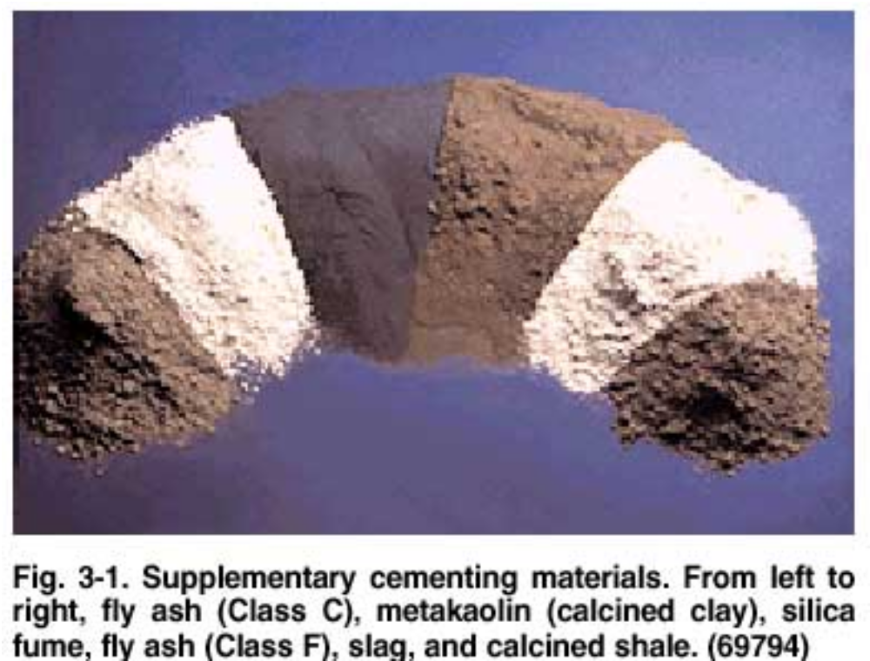

Supplementary cementing materials are added to concrete as part of the total cementing system. They may be used in addition to or as a partial replacement of Portland cement or blended cement in concrete, depending on the properties of the materials and the desired effect on concrete.
Supplementary cementing materials are used to improve a particular concrete property, such as the mitigation of deleterious alkali-aggregate reactivity.
Traditionally, fly ash, slag, silica fume and natural pozzolans such as calcined clay and calcined shale were used in concrete individually. Today, due to improved access to these materials, concrete producers can combine two or more of these materials to optimize concrete properties. Mixtures using three cementing materials, called ternary mixtures, are becoming more common.

Fly Ash
- Fly ash is a finely divided residue (a powder resembling cement) that results from the combustion of pulverized coal in electric power generating plants (See Fig. 3-2). Upon ignition in the furnace, most of the volatile matter and carbon in the coal are burned off.
- During combustion, the coal's mineral impurities (such as clay, feldspar, quartz, and shale) fuse in suspension and are carried away from the combustion chamber by the exhaust gases. In the process, the fused material cools and solidifies into spherical glassy particles called fly ash (See Fig. 3-3). The fly ash is then collected from the exhaust gases by electro-static precipitators or bag filters.
- Most of the fly ash particles are solid spheres and some are hollow cenospheres. The particle sizes in fly ash vary from less than 1 µm to more than 100 µm with the typical particle size measuring under 20 µm. The surface area is typically 300 to 500 m² /kg.
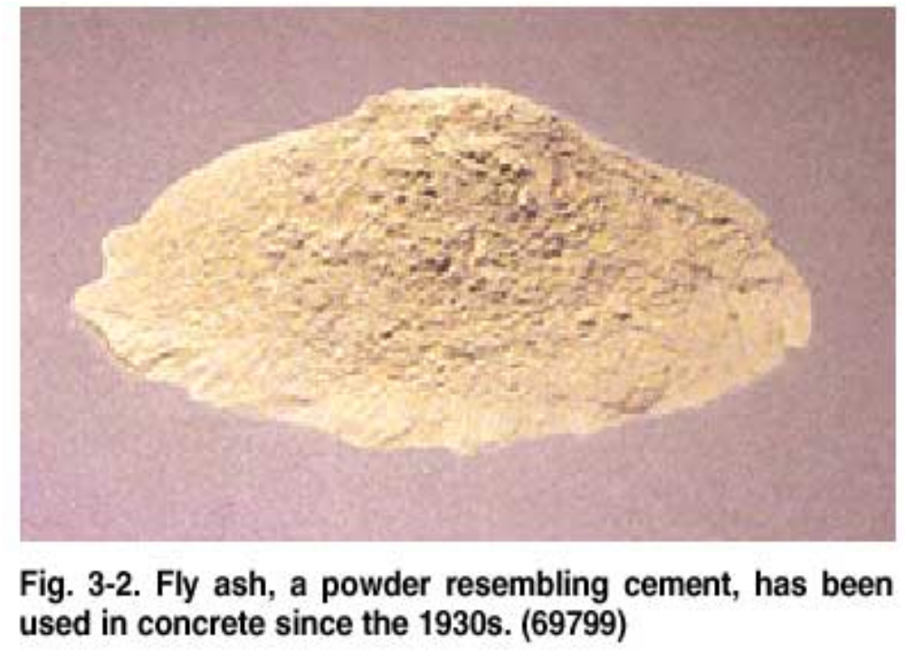
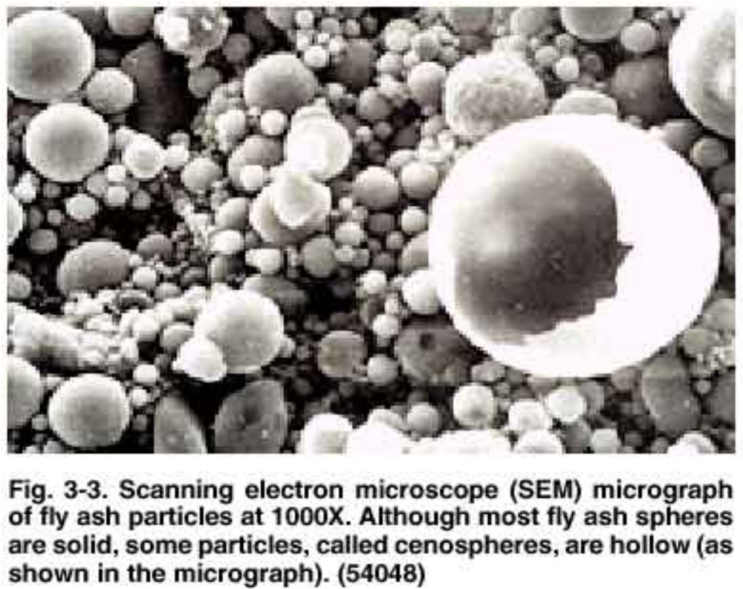

For fly ash without close compaction, the bulk density (mass per unit volume including air between particles) can vary from 540 to 860 kg/m 3 , whereas with close packed storage or vibration, the range can be 1120 to 1500 kg/m 3 .

Fly ash is primarily silicate glass containing silica, alumina, iron, and calcium. Minor constituents are magnesium, sulphur, sodium, potassium, and carbon. Crystalline compounds are present in small amounts. The relative density (specific gravity) of fly ash generally ranges between 1.9 and 2.8 and is generally tan or grey in colour.

Class F and Class C fly ashes are commonly used as pozzolanic admixtures for general purpose concrete.

- Class F materials are low-calcium (less than 8% CaO) fly ashes with carbon contents less than 5%, but some may be as high as 10%. Class C materials have higher calcium contents than Class F ashes. Class C ashes generally have carbon contents less than 2%. Many Class C ashes when exposed to water will hydrate and harden in less than 45 minutes.

Class F fly ash is often used at dosages of 15% to 25% by mass of cementing material and Class C fly ash is used at dosages of 15% to 40% by mass of cementing material. However, when concrete is to be deicer-scaling resistant, the maximum amount of fly ash used should be 25% by mass of the cementing material unless testing of the concrete to confirm adequate durability indicates otherwise.
Uses of fly ash, slag, and calcined clay
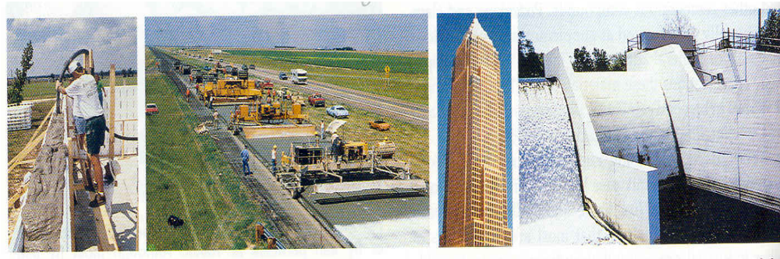
Silica Fume
- Silica fume, also referred to as microsilica or condensed silica fume, is a byproduct material that is used as a pozzolan (See Fig. 3-7). This byproduct is a result of the reduction of high-purity quartz with coal in an electric arc furnace in the manufacture of silicon or ferrosilicon alloy.
- Silica fume rises as an oxidized vapor from the 2000°C furnaces. When it cools it condenses and is collected in huge cloth bags. The condensed silica fume is then processed to remove impurities and to control particle size.
- Condensed silica fume is essentially silicon dioxide (usually more than 85%) in noncrystalline (amorphorous) form. Since it is an airborne material like fly ash, it has a spherical shape (See Fig. 3-8). It is extremely fine with particles less than 1 µm in diameter and with an average diameter of about 0.1 µm, about 100 times smaller than average cement particles.
- The relative density of silica fume is generally in the range of 2.20 to 2.25, but can be as high as 2.5. The bulk density of silica fume varies from 130 to 430 kg/m³. Silica fume is sold in powder form but is more commonly available in a liquid.

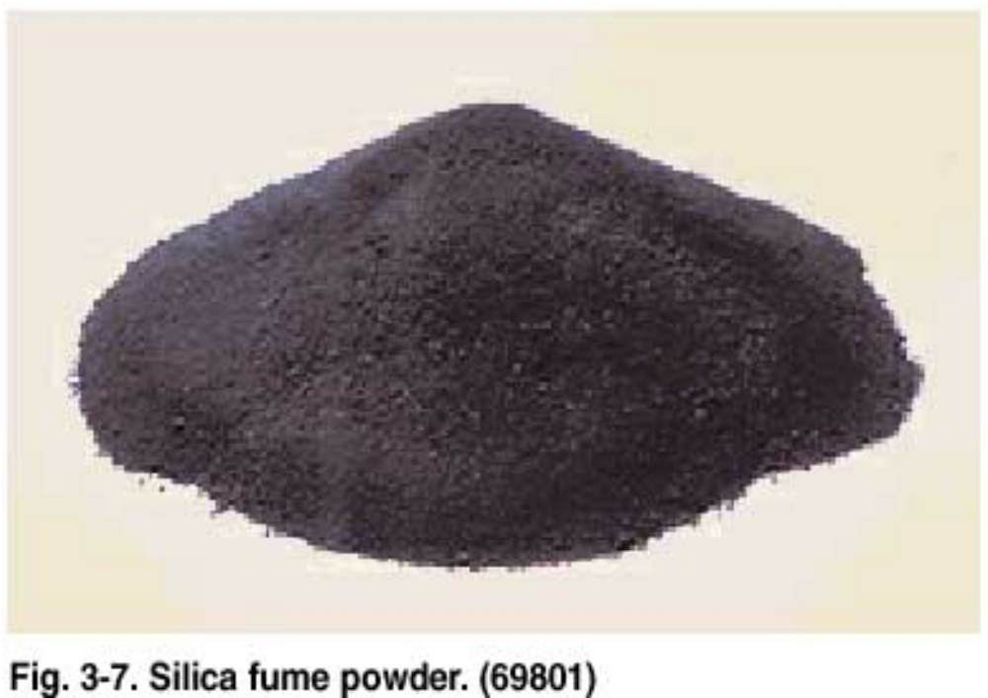

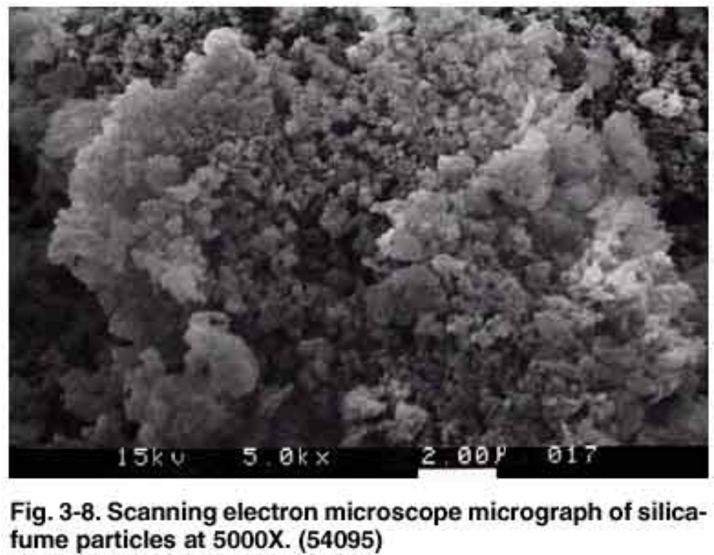

- Silica fume is used in amounts between 5% and 10% by mass of the total cementing material. It is used in applications where a high degree of impermeability is needed (See Fig. 3-9) and in high-strength concrete. In cases where the concrete must be deicer-scaling resistant.
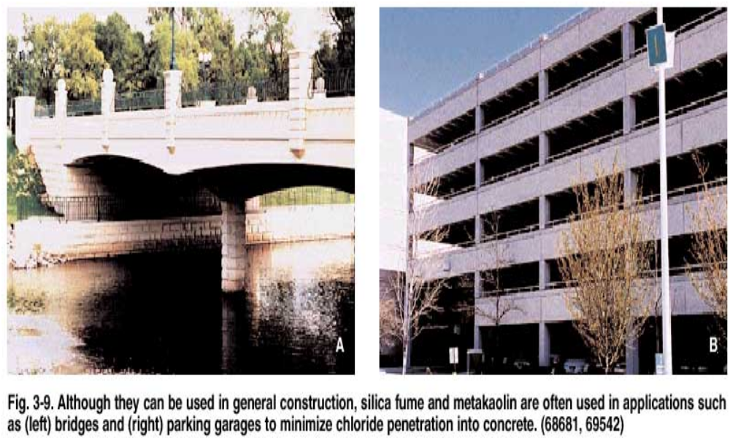

Slag
- Ground granulated blast furnace slag, also called slag cement, is made from iron blast-furnce slag; it is a nonmetallic hydraulic cement consisting essentially of silicates and aluminosilicates of calcium developed in a molten condition simultaneously with iron in a blast furnace.

- The molten slag at a temperature of about 1500°C is rapidly cooled by quenching in water to form a glassy sand like granulated material. The granulated material, which ground to less than 45 microns, has a surface area fineness of about 400 to 600 m2/kg. the relative density is in the range of 2.85 to 2.95. The bulk density varies from 1050 to 1375 kg/m³ .
- The slag cement has rough and angular-shaped particles, and in the presence of water and Ca (OH)₂ or NaOH supplied by Portland cement, it hydrates and sets in amanner similar to Portland cement.

Natural Pozzolans
- Natural pozzolans have been used for centuries. Many of the Roman, Greek, Indian, and Egyptian pozzolan concrete structures can still be seen today.
- The most common natural pozzolans used today are process materials, which are heat treated in a kiln and then ground to a finer powder, they include:
- Calcined clay,
- Calcined shale,
- Metakaolin.
Metakaolin (calcined clay ) 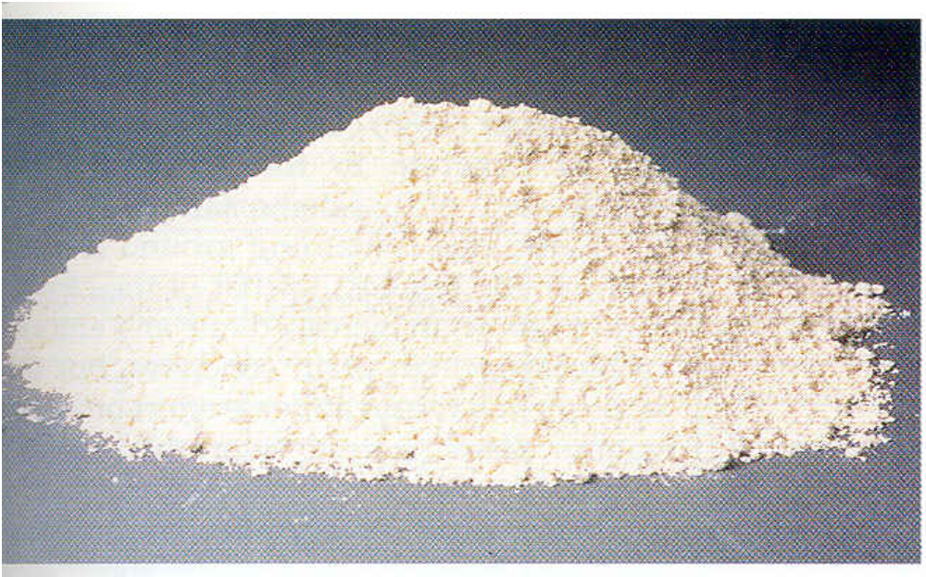

Chemical analysis of fly ash, slag, silica fume, calcied clay, calcied shale, and Metakaolin
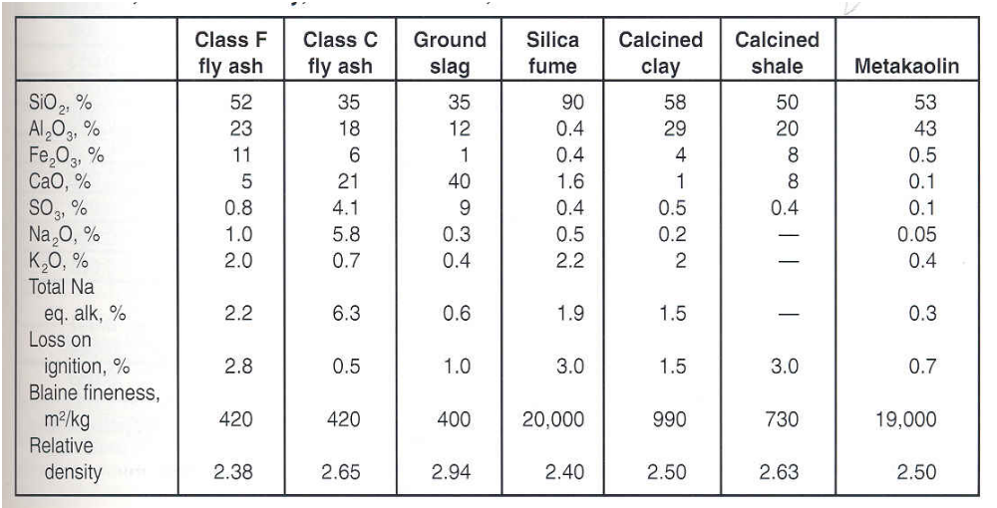

Effects on Freshly Mixed Concrete
Water Requirements
- Concrete mixtures containing fly ash generally require less water (1% to 10% less) for a given slump than concrete containing only Portland cement. Similarly ground slag decreases water demand by 1% to 10% depending on dosage.
- The water demand of concrete containing silica fume increases with increasing amounts of silica fume, unless water reducer or superplasticizer is used.
- Natural pozzolans have little effect on water demand at normal dosages.
Workability
- Fly ash, slag, and some natural pozzolans generally improve the workability of concretes of equal slump. While silica fume may reduce the workability and contribute to the stickiness of a concrete mixture.
Bleeding and Segregation
- Due to the reduced water demand, concretes with fly ash generally exhibit less bleeding and segregation than plain concretes.
- Ground slags (with similar fineness as cement) may increase the rate and amount of bleeding with no advers effect on segregation. Ground slags finer than cement reduce bleeding.
Setting Time
- Fly ash, ground slags, and natural pozzolans will generally increase the setting time of concrete. Silica fume may reduce the setting time of concrete.

Plastic Shrinkage Cracking
- Silica fume concrete may exhibit an increase in plastic shrinkage cracking due to the effect of low bleeding characteristics. Proper protection against drying is required during and after finishing. Other supplementary cementing materials that significantly increase setting time can increase the risk of plastic shrinkage.
Curing
- Concrete containing supplementary cementing materials need proper curing. The curing should start immediately after finishing. A seven-day moist curing or membrane curing should be applied. Some organizations specify at least 21 days of curing for all concrete containing pozzolanic materials.

Effect of slag on heat of hydration at 20ºC
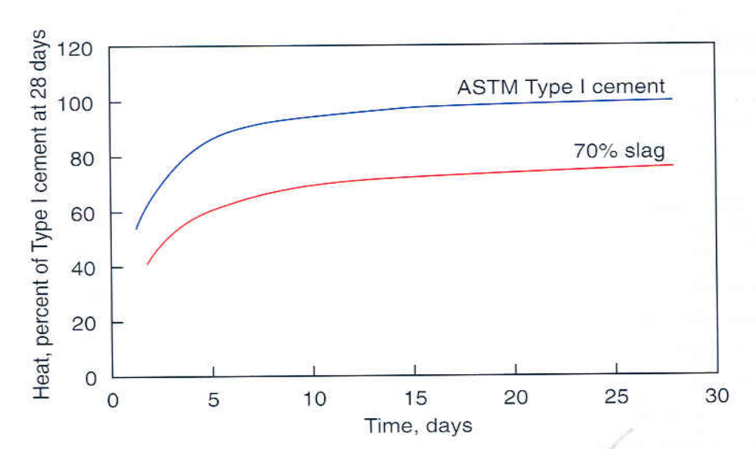

Effects on Hardened Concrete
Strength
- All supplementary materials contribute to the strength gain of concrete. However, the strength of concrete containing these materials can be higher or lower than concrete with only cementing materials.
Compressive strength development of different fly ashes (25%)
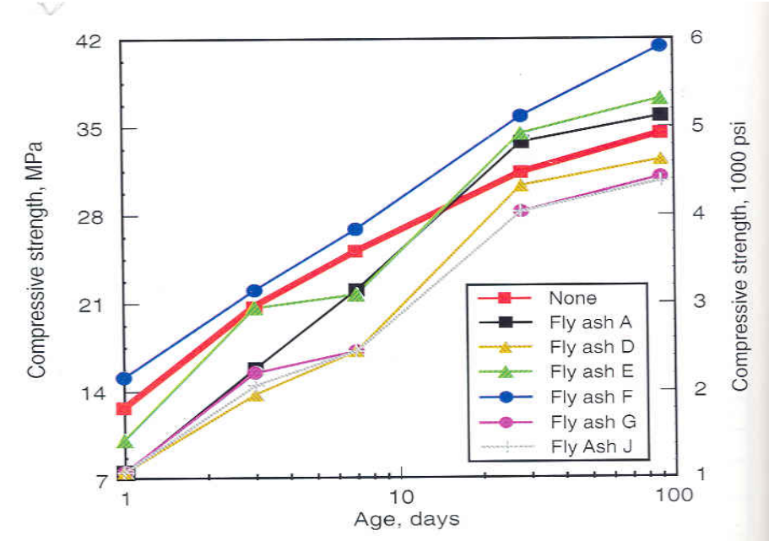

Strength
- The strength gain can be increased by one or combination of the following:
  - Increasing the amount of cementitious materials in concrete.
  - Adding high-early strength cementitious materials.
  - Decreasing the w/c ratio.
  - Increasing the curing temperature.
  - Using an accelerating admixture.
Compressive strength gain as % of 28-day strength
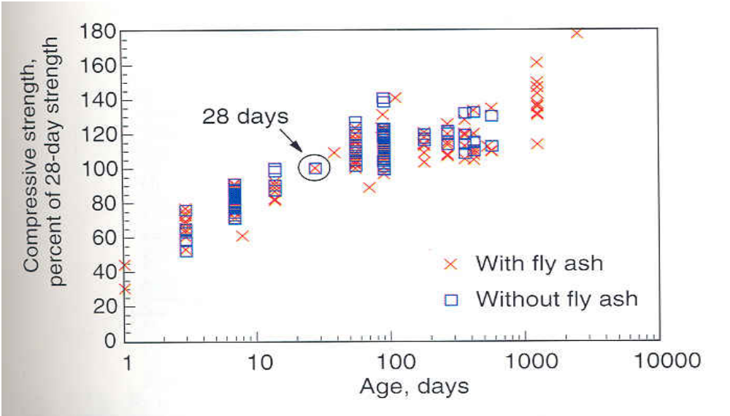

Drying Shrinkage and Creep
- When used in low to moderate contents, the effect of supplementary materials on the drying shrinkage and creep is small and of little practical significance.
Permeability and Absorption
- With adequate curing the concrete with supplementary materials will reduce the permeability and water absorption. Silica fume and other pozzolanic materials can improve the chloride resistance under 1000 Coulombs using ASTM C 1202.

Effect on alkali-silica reactivity
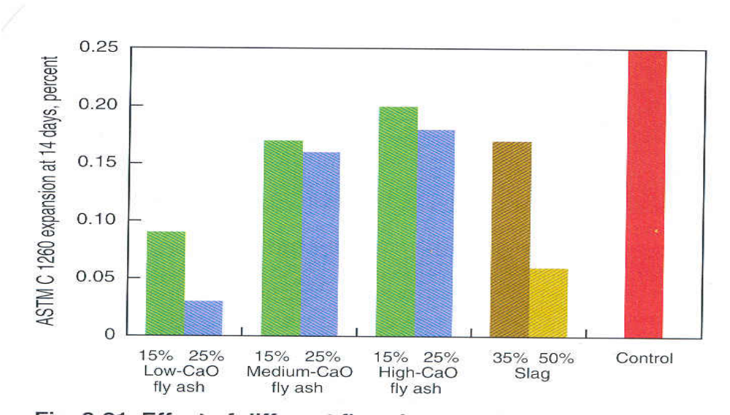

Reduction of alkali-silica reactivity
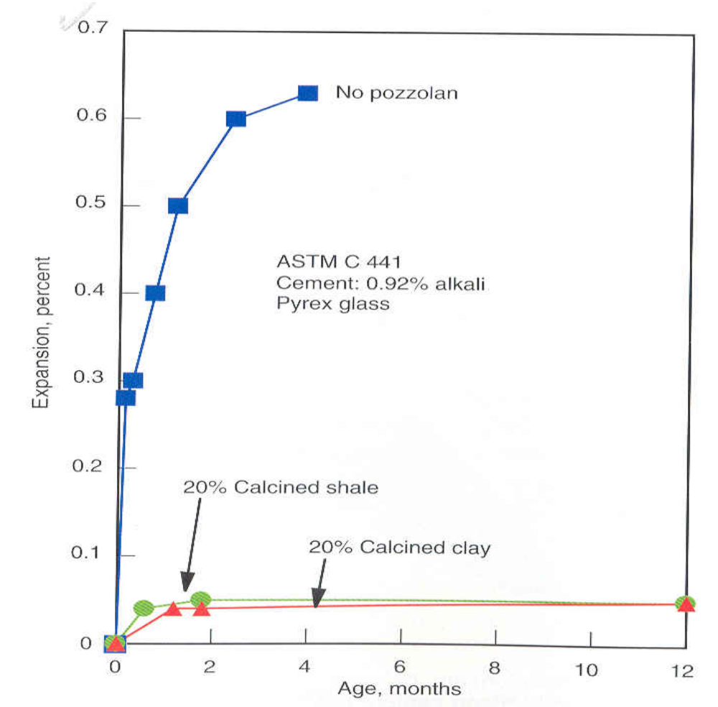
Sulfate Resistance
- The sulphate and seawater damaging effect on concrete can be reduced significantly by using silica fume, fly ash, and ground slag. The improvement can be reached by reducing the permeability and reducing the reactive materials such as calcium needed for expansive sulfate reactions.
Sulfate attack
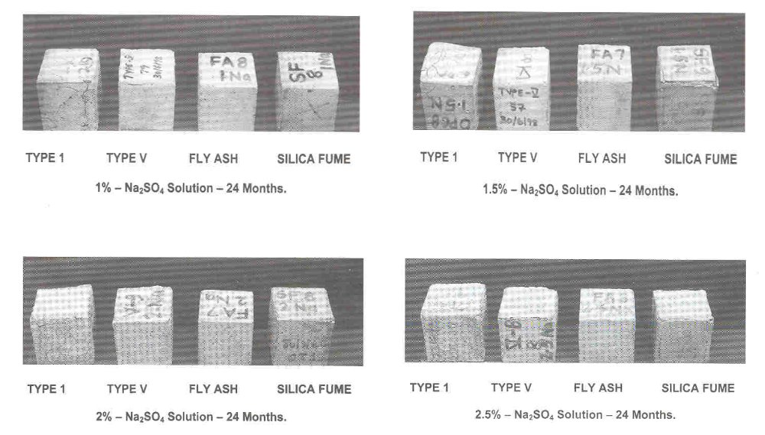
Sulfate attack

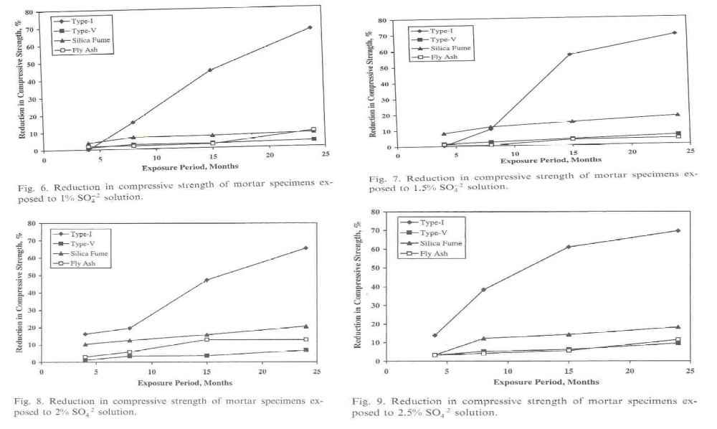

Sulfate attack
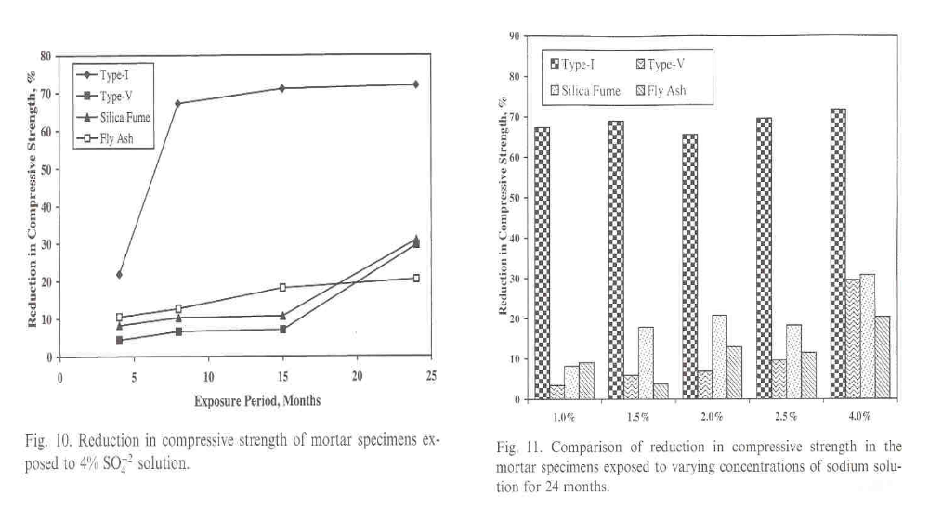

Corrosion of Embedded Steel
- The improvement in corrosion resistance of concrete can be achieved by reducing the permeability and increasing the electrical resistivity of concrete. Fly ash can reduce the permeability of concrete to water, air, and chloride ions. Silica fume greatly reduce the permeability and increase the electrical resistivity.

