Chlorohydrocarbon process
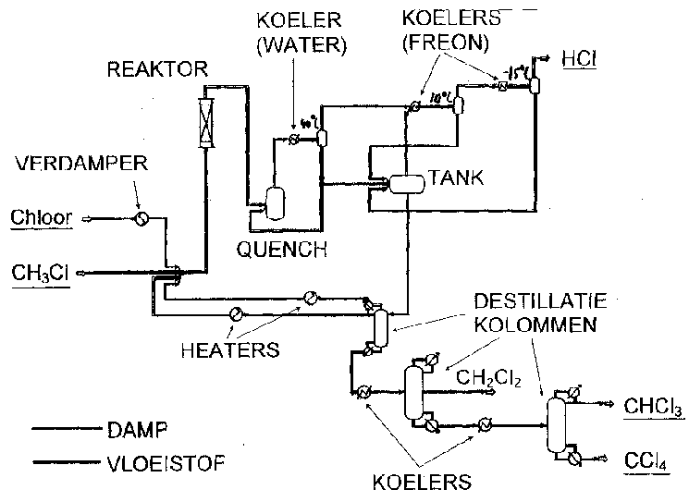
Industry: Bulk chemicals
Process: Production of chlorohydrocarbons
Technology: Reactor, distillation, heating, cooling
Application: Raw material for CFH and silicone

Short process description:
Methyl chloride reacts with gaseous chlorine into methylene chloride, chloroform en tetrachloride. The products are cooled in three steps down to -15 °C. HCl is still gaseous and is separated. The other products are separated in distillation columns (see figure 1).

CH₃Cl + Cl₂ à HCl + CH₂Cl₂ (methylenechloride)

CH₂Cl₂ + Cl₂ à HCl + CHCl₃ (chloroform)

CHCl₃ + Cl₂ à HCl + CCl₄ (tetrachloride)
Figure 1: Production process for chlorohydrocarbons

Exergy analysis:

Part of process | Exergy loss (MW) | Cause
Reactor | 1.9 | Chemical
Quench | 1.0 | Mixing of hot and cold streams
First cooler | 1.0 | High discharge temperature of cooling water
Distillation columns | 5.0 | Temperature difference in condenser en reboiler
Remaining | 0.9 | -
Total | 9.8
Table 1: Exergy loss during the production of chlorohydrocarbons

Process modifications
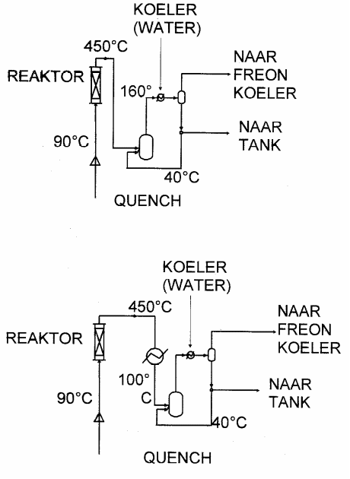
- Recover heat of reaction (450 °C) to produce high-pressure steam in stead of cooling with cooling water. (see figure 2)
- Raise cooling temperature freon from -40 °C to -38 °C
- Reduce cooling power by recycling cold streams
- Evaporate chlorine at 1 bar(a) instead of 10 bar(a) à use air in stead of steam
- Combining 2 distillation columns à less condensing and evaporating

Energy savings:

Process modification | Savings steam  [ton/h] | Savings electricity  [kW]
1. Heat of reaction | 4 | -
2. Cooling temperature | - | -
3. Recycling cold streams | - | 51
4. Evaporating with air | 1 | 54
5. Combining distillation columns | 4 | -
Table 2: Energy savings of the proposed process modifications

Possibilities for applications in other industries
- Chemicals
- Food industry
Figure 2: Process modification 1: Recovering heat of reaction

Keywords:
Bulk chemicals, distillation, cooling, chlorohydrocarbons, chloroform, tetrachloride

