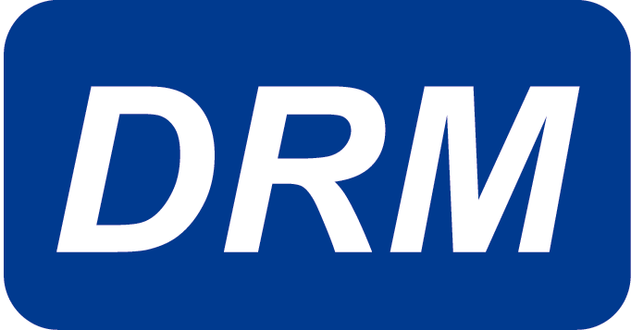

Design & Process FMEA

The purpose of the Design and Process Failure Mode Effects Analysis (FMEA) workshop is to provide participants with the skills and knowledge required to complete an FMEA in a team environment. The Design FMEA focuses on potential failure modes caused by design deficiencies and performed on the components and perishable tooling. The Design FMEA may provide inputs to the FMEA performed on machinery, equipment, tooling, process, and design. In this instructor-led workshop, participants will learn the purpose of the FMEA, when and why to initiate the FMEA process, the duties and responsibilities of the team members, and how to complete the FMEA and fault tree analysis. These steps will be accomplished through dynamic group interaction and hands-on application.

Workshop Duration: 2 days

Class Size: 10 minimum

Who Should Machinery Personnel
Attend: Machinery Suppliers
Manufacturing Engineers
Operators
Quality and Tooling Engineers
Skilled Trades

Workshop Cost: Call for latest pricing and group discount rates.
Price includes student workbook and certificate of completion.

Workshop Workshop can be conducted at DRM Technologies’
Location: Manufacturing Learning Institute or at the customer’s site.

