SURFACE VEHICLE RECOMMENDED PRACTICE

POTENTIAL FAILURE MODE AND EFFECTS ANALYSIS IN DESIGN (DESIGN FMEA), POTENTIAL FAILURE MODE AND EFFECTS ANALYSIS IN MANUFACTURING AND ASSEMBLY PROCESSES (PROCESS FMEA), AND POTENTIAL FAILURE MODE AND EFFECTS ANALYIS FOR MACHINERY (MACHINERY FMEA).

Draft
Proposal from the SAE J1739 Main Working Committee

William Carlson - DaimlerChrysler
Carl Carlson - General Motors
Glen Vallance and Cynthia Taaffee - Ford

With Machinery Working Sub-Committee
David Janas - DaimlerChrysler
Adhi Kersala - General Motors
Gary Givens - Ford

NOTE:
Format of this Review Document:

Changes to the Original SAE J1739 document in the Introduction and Design and Process FMEA sections have been highlighted for ease of comparison. Text that is bold and italicize is new or revised.

The Machinery FMEA section is completely new and has not been bolded or italicized for purposes of readability.

Final Format of the Standard is pending approval of content. This document is being provided for ‘content’ related comments only.
1. Scope—General Information

1.1 Overview—This SAE Recommended Practice was jointly developed by DaimlerChrysler, Ford, and General Motors.

This document introduces the topic of potential Failure Mode and Effects Analysis (FMEA) and gives general guidance in the application of the technique.
All FMEA’s focus on the design, whether it be of the product, the process or the machinery used to build the product. An Applications Section (see Section 5) has been added to provide information on applying the FMEA technique to plant machinery and equipment using the Machinery FMEA (MFMEA).

- Recommended Practice Format—For ease of use, this reference document presents the two basic types of FMEA (Design FMEA and Process FMEA) in their own separate sections. This document also contains an Applications Section (Section 5) which discusses in some detail how an FMEA is applied to Plant Machinery and Equipment (Machinery FMEA).

The Machinery FMEA (MFMEA) information has been provided due to the importance of Plant Machinery and Equipment functioning as intended in manufacturing and assembly plants. The use of the MFMEA, on Plant Machinery and Equipment, will assist with the identification of potential failure modes, so that design and processing alternatives can be considered, prior to finalizing the Plant Machinery and Equipment Designs.

It should be noted that this document is a recommended practice, and as such, each Team is free to use the guidelines listed herein in the manner which will be most effective for a given situation. Section 5.2.17.1 contains a table of "Suggested Detection Evaluation Criteria" for MFMEA which has rankings of 10, 7, 5, 3, and 1 (does not contain rankings of 9, 8, 6, 4, and 2). This Applications Section Detection Table illustrates that the Team can make modifications to the standard format of 10-1 rankings, if this will be most effective for the Team's situation and application.

Figure 1 illustrates an approximate time line where the Design FMEA (DFMEA) for the product is started somewhat before the Process FMEA (PFMEA) for producing the product. Figure 1 shows that the Machinery FMEA (MFMEA) should be started at about the same time as the PFMEA. The "OEM Product Development Time Line" refers to the "Original Equipment Manufacturer's Time Line" which is used for the design, development, and production of the product. In some situations, all three FMEAs (i.e., DFMEA, PFMEA, and MFMEA) might be started at the same time. In general, the earlier that FMEAs are started, the better the chances of optimizing the various activities/designs/processes in a cost and time effective manner.

FIGURE 1

1.3 What is an FMEA? - An FMEA can be described as a systemized group of activities intended to: (a) recognize and evaluate the potential failure of a product/process and its effects, (b) identify actions which could eliminate or reduce the chance of the potential failure occurring, and (c) document the process. It is complementary to the process of defining what a design or process must do to satisfy the customer.

1.4 FMEA Implementation—Because of the general industry trend to continually improve products and processes whenever possible, the need for using the FMEA as a disciplined technique to identify and help minimize potential concern is as important as ever. Studies of vehicle campaigns have shown that fully implemented FMEA programs could have prevented many of the campaigns.

One of the most important factors for the successful implementation of an FMEA program is timeliness. It is meant to be a "before-the-event" action, not an "after-the-fact" exercise. To achieve the greatest value, the FMEA must be done before a product or process failure mode has been incorporated into a product or process. Up front time spent properly completing an FMEA, when product/process changes can be most easily and inexpensively implemented, will minimize late change crises. An FMEA can reduce or eliminate the chance of implementing a preventive/corrective change which would create an even larger concern. Communication and coordination should occur between all types of FMEAs ( i.e. Design - DFMEA, Process - FMEA, and Machinery - MFMEA). (See Figure 1).

Figure 2

FMEA Process Sequence
Figure 2 depicts the sequence in which an FMEA should be performed. It is not simply a case of filling out the column, but rather understanding the process and how to eliminate risk and plan the appropriate controls to protect customer satisfaction.

There are three basic cases for which FMEA’s are generated, each with a different scope or focus:

Case 1: New designs, new technology, or new process.
The scope of the FMEA is the complete design, technology or process.

Case 2: Modifications to existing design or process (assumes there is a FMEA for the
existing design or process).
The scope of the FMEA should focus on the modification to design or
process, possible interactions due to the modification, and field history.

Case 3: Use of existing design or process in a new environment, location
or application (assumes there is an FMEA for the existing design or
process). The scope of the FMEA is the impact of the new environment or
location on the existing design or process.

Although responsibility for the preparation of the FMEA is usually assigned to an individual, FMEA input should be a team effort. A team of knowledgeable individuals should be assembled (e.g., engineers with expertise in Design, Analysis/Testing, Manufacturing, Assembly, Service, Recycling, Quality, and Reliability). The FMEA is initiated by the engineer from the responsible activity, which can be the Original Equipment Manufacturer (i.e., produces the final product), supplier or a subcontractor.

It is not appropriate to compare the ratings of one team's FMEA with the ratings of another team's FMEA, even if the product/process appear to be identical, since each team environment is unique and thus their respective individual ratings will be unique (i.e., the ratings are subjective).

Review of the FMEA document against FMEA quality objectives (see Appendix A and Appendix B) is recommended including a management review.

1.5 FOLLOW-UP— The need for taking specific, preventive/corrective actions with quantifiable benefits, recommending actions to other activities and following-up all recommendations cannot be overemphasized. A thoroughly thought out and well developed FMEA will be of limited value without positive and effective preventive/corrective actions.

The responsible engineer is in charge of assuring that all recommended actions have been implemented or adequately addressed. The FMEA is a living document and should always reflect the latest level, as well as the latest relevant actions, including those occurring after the start of production.

The responsible engineer has several means of assuring that recommended actions are implemented. They include, but are not limited to the following:

- Assuring design/process/machine requirements are achieved
- Review of engineering drawings, processes and specifications
- Confirmation of incorporation of changes to
design/assembly/manufacturing documentation
- Review of Design/Process FMEAs, special FMEA applications such as
Machinery FMEA and Control Plans

2. References—There are no referenced publications specified herein.

FIGURE 3 scanned image, figure to be updated
Add to Column:
--Prevention
--Detection
Add Model Year / Program and
Delete Vehicle from
upper left hand header.
SECTION 3
Potential Failure Mode and Effects Analysis in Design (Design FMEA)
Add to heading:
Prevention
Detection
Add Model year /and program and delete
vehicle

3. Potential Failure Mode and Effects Analysis in Design (Design FMEA)

- Introduction— A Design potential FMEA is an analytical technique utilized primarily by a Design Responsible Engineer/Team as a means to assure that, to the extent possible, potential failure modes and their associated causes/mechanisms have been considered and addressed. End items, along with every related system, subassembly and component, should be evaluated. In its most rigorous form, an FMEA is a summary of the team's thoughts (including an analysis of items that could go wrong based on experience) as a component, subsystem, or system is designed. This systematic approach parallels, formalizes, and documents the mental disciplines that an engineer normally goes through in any design process.

The Design potential FMEA supports the design process in reducing the risk of failures (including unintended outcomes) by:

- Aiding in the objective evaluation of design, including functional requirements and design alternatives.
- Evaluating the initial design for manufacturing, assembly, service, and recycling requirements.
- Increasing the probability that potential failure modes and their effects on system and vehicle operation have been considered in the design/development process.
- Providing additional information to aid in the planning of thorough and efficient design, development, and validation programs.
- Developing a ranked list of potential failure modes according to their effect on the "customer," thus establishing a priority system for design improvements, development and validation testing/analysis.
- Providing an open issue format for recommending and tracking risk reducing actions.
- Providing future reference, e.g. lessons learned, to aid in analyzing field concerns, evaluating design changes and developing advanced designs.

3.1.1 CUSTOMER DEFINED—The definition of "CUSTOMER" for a Design potential FMEA is not only the "END USER," but also the design responsible engineers/teams of the vehicle or higher level assemblies, and/or the manufacturing process responsible engineers in activities such as Manufacturing, Assembly, and Service.

3.1.2 TEAM EFFORT—During the initial Design potential FMEA process, the responsible engineer is expected to directly and actively involve representatives from all affected areas. These areas of expertise and responsibility should include, but are not limited to: assembly, manufacturing, design, analysis/test, reliability, materials, quality, service, and suppliers, as well as the design area responsible for the next higher or lower assembly or system, sub-assembly or component. The FMEA should be a catalyst to stimulate the interchange of ideas between the functions affected and thus promote a team approach.

Unless the responsible engineer is experienced with FMEA and team facilitation, it is helpful to have an experienced FMEA Facilitator assist the team in its activities.

The Design FMEA is a living document and should:
- be initiated before or at design concept finalization,
- be continually updated as changes occur or additional information is obtained throughout the phases of product development,
- and be fundamentally completed before the production drawings are released for tooling.

Considering that manufacturing/assembly needs have been incorporated, the Design FMEA addresses the design intent and assumes the design will be manufactured/assembled to this intent. Potential failure modes and/or causes/mechanisms which can occur during the manufacturing or assembly process need not, but may be included in a Design FMEA. When not included, their identification, effect and control are covered by the Process FMEA.

The Design FMEA does not rely on process controls to overcome potential design weaknesses, but it does take the technical/physical limits of a manufacturing/assembly process into consideration, e.g.:

- Necessary mold drafts
- Limited surface finish
- Assembling space/access for tooling
- Limited hardenability of steels
- Tolerances/process capability/performance

The Design FMEA can also take into consideration the technical/physical limits of product maintenance (service) and recycling, e.g.:

- tool access
- diagnostic capability
- material classification symbols (for recycling)

3.2 Development of a Design FMEA—The design responsible engineer has at their disposal a number of documents that will be useful in preparing the Design FMEA. The process begins by developing a listing of what the design is expected to do, and what it is expected not to do, i.e., the design intent. Customer wants and needs, as may be determined from sources such as Quality Function Deployment (QFD), Vehicle Requirements Documents, known product requirements and/or manufacturing/assembly/service/recycling requirements should be incorporated. The better the definition of the desired characteristics, the easier it is to identify potential failure modes for preventive/corrective action.

A Design FMEA can begin with a block diagram, for the system, subsystem, and/or component being analyzed.

An example block diagram is shown in Appendix C. The block diagram can also indicate the flow of information, energy, force, fluid, etc. The object is to understand the deliverables (input) to the block, the process (function) performed in the block, and the deliverables (output) from the block.

The diagram illustrates the primary relationship between the items covered in the analysis and establishes a logical order to the analysis. Copies of the diagrams used in FMEA preparation should accompany the FMEA.

In order to facilitate documentation of the analysis of potential failures and their consequences, a blank form is available in Appendix D.

An example of a completed form is contained in Appendix E.

3.2.1 (1) FMEA NUMBER—Enter the FMEA document number, which may be used for tracking. (See FIGURE 3)

3.2.2 (2) SYSTEM, SUBSYSTEM, OR COMPONENT NAME AND NUMBER—Indicate the appropriate level of analysis and enter the name and number of the system, subsystem, or component being analyzed. The FMEA team must decide on what constitutes a system, sub-system, or component for their specific activities. The actual boundaries that divide a System, Sub-System, and Component are arbitrary and must be set by the FMEA team. Some descriptions are provided below and some examples are provided in Appendix F (See FIGURE 3.)

3.2.2.1 System FMEA Scope
A system can be considered to be made up of various sub-systems. These sub-systems often have been designed by different teams. Some typical System FMEAs might cover the following systems: Chassis System, or Powertrain System, or Interior System, etc. Thus, the focus of the System FMEA is to ensure that all interfaces and interactions between the various sub-systems that make up the system as well as interfaces to other vehicle systems and the customer are covered.

3.2.2.2 Sub-System FMEA Scope
A sub-system FMEA is generally a sub-set of a larger system. For example, the front suspension sub-system is a sub-set of the chassis system. Thus, the focus of the Sub-System FMEA is to ensure that all interfaces and interactions between the various components that make up the sub-system are covered in the Sub-System FMEA.

3.2.2.3 Component FMEA Scope
A component FMEA is a generally an FMEA focused on the sub-set of a sub-system. For example, a strut is a component of the front suspension (which is a sub-system of the chassis system.)

3.2.3 (3) DESIGN RESPONSIBILITY—Enter the OEM, department, and group. Also include the supplier name if applicable. (See FIGURE 3.)

3.2.4 (4) PREPARED BY—Enter the name, telephone number, and company of the engineer responsible for preparing the FMEA. (See FIGURE 3.)

3.2.5 (5) MODEL YEAR(S)/PROGRAM(S)---Enter the intended model year(s) and program(s) that will utilize and/or be affected by the design being analyzed (if known). (See FIGURE 3.)

3.2.6 (6) KEY DATE—Enter the initial FMEA due date, which should not exceed the scheduled production design release date. (See FIGURE 3.)

3.2.7 (7) FMEA DATE—Enter the date the original FMEA was compiled, and the latest revision date. (See FIGURE 3.)

3.2.8 (8) TEAM—List the names of the responsible individuals and departments which have the authority to identify and/or perform tasks. (It is recommended that all team members names, departments, telephone numbers, addresses, etc., be included on a distribution list). (See FIGURE 3.)

3.2.9 (9) ITEM/FUNCTION—Enter the name and other pertinent information (e.g., the number , the part class, etc.) of the item being analyzed. Use the nomenclature and show the design level as indicated on the engineering drawing. Prior to initial release (e.g., in the conceptual phases), experimental numbers should be used. (See Figure 3.)

Enter, as concisely as possible, the function of the item being analyzed to meet the design intent. Include information (metrics/measurables) regarding the environment in which this system operates (e.g., define temperature, pressure, humidity ranges, design life). If the item has more than one function with different potential modes of failure, list all the functions separately.

3.2.10 (10) POTENTIAL FAILURE MODE—Potential Failure Mode is defined as the manner in which a component, subsystem, or system could potentially fail to meet or deliver the intended function described in the item/function column (i.e., intended function fails ). The potential failure mode may also be the cause of a potential failure mode in a higher level subsystem, or system, or be the effect of one in a lower level component. (See Figure 3.)

List each potential failure mode associated with the particular item and item function. The assumption is made that the failure could occur, but may not necessarily occur. A recommended starting point is a review of past things-gone-wrong, concerns, reports, and group brainstorming.

Potential failure modes that could only occur under certain operating conditions (i.e., hot, cold, dry, dusty, etc.) and under certain usage conditions (i.e., above average mileage, rough terrain, only city driving, etc.) should be considered.

Typical failure modes could be, but are not limited to:

cracked deformed loosened
leaking sticking oxidized
fractured does not transmit torque slips (does not hold full torque)
no support (structural) inadequate support (structural) harsh engagement
disengages too fast inadequate signal intermittent signal
no signal EMC/RFI drift

NOTE— Potential failure modes should be described in "physical" or technical terms, not as a symptom necessarily noticeable by the customer.

- (11) POTENTIAL EFFECT(S) OF FAILURE—Potential Effects of Failure are defined as
the effects of the failure mode on the function, as perceived by the customer. (See
Figure 3 and Section 3.1.1)

Describe the effects of the failure in terms of what the customer might notice or experience, remembering that the customer may be an internal customer as well as the ultimate end user. State clearly if the function could impact safety or non-compliance to regulations. The effects should always be stated in terms of the specific system, subsystem, or component being analyzed. Remember that a hierarchical relationship exists between the component, subsystem, and system levels. For example, a part could fracture, which may cause the assembly to vibrate, resulting in an intermittent system operation. The intermittent system operation could cause performance to degrade, and ultimately lead to customer dissatisfaction. The intent is to forecast the failure effects, to the team's level of knowledge.

Typical failure effects could be, but are not limited to:

Noise Rough Leaks
Erratic Operation Inoperative Regulatory Non-Compliance
Poor Appearance Unpleasant Odor
Unstable Operation Impaired
Intermittent Operation Thermal Event

- (12) SEVERITY (S)—Severity is the rank associated with the most serious effect from the previous column. Severity is a relative ranking, within the scope of the individual FMEA. A reduction in Severity Ranking index can be effected only through a design change. Severity should be estimated using the following table as a guideline:

3.2.12.1 Suggested Evaluation Criteria—The team should agree on an evaluation criteria and ranking system, which is consistent, even if modified for individual product analysis. (See Table 1.)

NOTES - 1) It is not recommended to modify criteria ranking values of 9 & 10. Failure Modes with rank Severity 1, should not be analyzed further. 2) High Severity Rankings can sometimes be reduced by making design revisions that compensate or mitigate the resultant severity of failure. For example, "run flat tires" can mitigate the severity of a sudden tire blowout and "seat belts" can mitigate the severity of a vehicle crash.

Table 1 – Suggested DFMEA Severity Evaluation Criteria

Effect | Criteria: Severity of Effect | Ranking
Hazardous  without  warning | Very high severity ranking when a potential failure mode affects safe vehicle operator and/or involves noncompliance with government regulation without warning. | 10
Hazardous  with warning | Very high severity ranking when a potential failure mode affects safe vehicle operator and/or involves noncompliance with government regulation with warning. | 9
Very High | Vehicle/item inoperable (loss of primary function). | 8
High | Vehicle/Item operable but at a reduced level of performance. Customer very dissatisfied. | 7
Moderate | Vehicle/Item operable but Comfort/Convenience item(s) inoperable. Customer dissatisfied. | 6
Low | Vehicle/Item operable but Comfort/Convenience item(s) operable at a reduced level of performance. Customer somewhat dissatisfied. | 5
Very Low | Fit & finish/Squeak & rattle item does not conform. Defect noticed by most customers (greater than 75%). | 4
Minor | Fit & finish/Squeak & rattle item does not conform. Defect noticed by 50 percent of customers. | 3
Very Minor | Fit & finish/Squeak & rattle item does not conform. Defect noticed by discriminating customers (less than 25 percent). | 2
None | No discernible effect. | 1

3.2.13 (13) CLASSIFICATION—This column may be used to classify any special product characteristics (e.g., critical, key, major, significant) for components, subsystems, or systems that may require additional design or process controls. (See FIGURE 3.)

This column may also be used to highlight high priority failure modes for engineering assessment, if the Team finds this helpful, or if local management requires same.

Special Product or Process Characteristic symbols and their usage is directed by specific company policy and is not standardized in this recommended practice.

3.2.14 (14) POTENTIAL CAUSE(S)/MECHANISM(S) OF FAILURE—Potential Cause of Failure is defined as an indication of a design weakness, the consequence of which is the failure mode. (See FIGURE 3.)

List, to the extent possible, every potential cause and/or failure mechanism for each failure mode. The cause/mechanism should be listed as concisely and completely as possible so that remedial efforts can be aimed at pertinent causes.

Typical failure causes may include, but are not limited to:

Incorrect Material Specified Inadequate Design Life Assumption
Over-stressing Insufficient Lubrication Capability Inadequate Maintenance Instructions Incorrect Algorithm
Improper Maintenance Instructions Improper Software Specification
Improper Surface Finish Specification Inadequate Travel Specification
Improper Friction Material Specified Excessive Heat
Tolerance Stack Up

Typical failure mechanisms may include, but are not limited to:

Yield Chemical Oxidation
Fatigue Electromigration
Material Instability
Creep
Wear
Corrosion

For Severity rankings 9 or 10, it is recommended that causes be taken to a root cause level and be entered on the form in this column.

3.2.15 (15) OCCURRENCE (O)—Occurrence is the likelihood that a specific cause/mechanism (listed in the previous column) will occur during the design life. The likelihood of occurrence ranking number has a relative meaning rather than an absolute value. Preventing or controlling the causes/mechanisms of the failure mode through a design change or design process change (e.g. design checklist, design review, design guide) is the only way a reduction in the occurrence ranking can be effected. (See FIGURE 3.)

Estimate the likelihood of occurrence of potential failure cause/mechanism on a "1" to "10" scale. In determining this estimate, questions such as the following should be considered:

a. What is the service history/field experience with similar components, subsystems or systems?
- Is component carryover or similar to a previous level component,
subsystem or system?
- How significant are changes from a previous level component, subsystem or
system?
d. Is component radically different from a previous level component?
e. Is component completely new?
f. Has the component application changed?
g. What are the environmental changes?
- Has an engineering analysis (e.g. reliability) been used to estimate the
expected comparable occurrence rate for the application?
i. Have preventive controls been put in place?

A consistent occurrence ranking system should be used to ensure continuity. The occurrence ranking number is a relative rating within the scope of the FMEA and may not reflect the actual likelihood of occurrence.

3.2.15.1 Suggested Evaluation Criteria—The team should agree on an evaluation criteria and ranking system, which is consistent, even if modified for individual product analysis. (See Table 2.) Occurrence should be estimated using the following table as a guideline:

NOTE - The ranking value of 1 is reserved for “Remote: Failure Is unlikely”.

Table 2 – Suggested DFMEA Occurrence Evaluation Criteria

Probability of Failure | Likely Failure Rates Over Design Life | Ranking
Very High: Persistent failures | ≥100 per thousand vehicles/items | 10
 | 50 per thousand vehicles/items | 9
High: Frequent  failures | 20 per thousand vehicles/items | 8
 | 10 per thousand vehicles/items | 7
Moderate: Occasional failures | 5 per thousand vehicles/items | 6
 | 2 per thousand vehicles/items | 5
 | 1 per thousand vehicles/items | 4
Low: Relatively few failures | 0.5 per thousand vehicles/items | 3
 | 0.1 per thousand vehicles/items | 2
Remote: Failure is unlikely | ≤ 0.01 per thousand vehicles/items | 1

3.2.16 (16) CURRENT DESIGN CONTROLS—List the prevention, design validation/verification (DV), or other activities which are completed or committed to and that will assure the design adequacy for the failure mode and/or cause/mechanism under consideration. Current controls (e.g., road testing, design reviews, fail/safe designs such as a pressure relief valve, mathematical studies, rig/ lab testing, feasibility review, prototype tests, fleet testing) are those that have been or are being used with the same or similar designs. (See FIGURE 3.) The Team should always be focused on improving design controls, for example, the creation of new system tests in the lab, or the creation of new system modeling algorithms, etc.

There are two types of Design Controls/features to consider:

Type 1. Prevention: Prevent the cause/mechanism or failure mode/effect from
occurring, or reduce the rate of occurrence,
Type 2. Detection: Detect the cause/mechanism or failure mode, either by
analytical or physical methods, before the item is released to
production.

The preferred approach is to first use type (1) controls if possible. The initial occurrence rankings will be affected by the type (1) controls provided they are integrated as part of the design intent. The initial detection rankings will be based on the type (2) current controls, assuming the prototypes and models being used are representative of design intent.

- (17) DETECTION (D)— Detection is the rank associated with the best type (2) design
control from the list in the previous column. Detection is a relative ranking, within the
scope of the individual FMEA. In order to achieve a lower ranking, generally the
planned design control (e.g. validation, and/or verification activities) has to be improved.

- Suggested Evaluation Criteria—The team should agree on an evaluation criteria and ranking system, which is consistent, even if modified for individual product analysis. (See Table 3.)

3.2.17.2 It is best to have type two design controls in place as early as possible in the design development process. Note: After making the Detection Ranking, the Team should review the Occurrence Ranking and ensure that the Occurrence Ranking is still appropriate, based on the Detection Ranking.

Detection should be estimated using the following table as a guideline:

Note: The ranking value of 1 is reserved for “almost certain.”

3.2.18 (18) RISK PRIORITY NUMBER (RPN)—The Risk Priority Number is the product
of the Severity (S), Occurrence (O), and Detection (D) ranking. (See FIGURE 3).

RPN = (S) x (O) x (D) (Equation 1)

Within the scope of the individual FMEA, this value (between “1” and
“1000”) can be used to rank order the concerns in the design (e.g., in Pareto
fashion).

3.2.19 (19) RECOMMENDED ACTION(s)- Engineering assessment for preventive/corrective action should be first directed at high severity, high RPN and other items designated by the team. The intent of any recommended action is to reduce rankings, in the following preference order: severity, occurrence, and detection rankings. (See FIGURE 3).

In general practice when the severity is a “9” or “10”, special attention must be given to assure that the risk is addressed through existing design controls or preventative or corrective action(s), regardless of the RPN. In all cases where the effect of an identified potential failure mode could be a hazard to the end-user, preventive/corrective actions should be considered to avoid the failure mode by eliminating, mitigating or controlling the cause(s).

After special attention has been given to Severity(s) of 9 or 10, the team then addresses other Failure Modes, with the intent of reducing Severity, then Occurrence and then Detection.

Actions such as, but are not limited to, the following should be considered:

a. Revised Design Geometry and/or tolerances
b. Revised Material Specification
- Design of experiments (particularly when multiple or interactive causes are present)/or other problem solving techniques.
d. Revised Test Plan

The primary objective of recommended actions is to reduce risks and increase customer satisfaction by improving the design.

Only a design revision can bring about a reduction in the severity ranking. A reduction in the occurrence ranking can be effected only by removing or controlling one or more of the causes/mechanisms of the failure mode through a design revision. An increase in design validation/verification actions will result in a reduction in the detection ranking only. Increasing the design validation/verification actions is a less desirable engineering action since it does not address the severity or occurrence of the failure mode.

If engineering assessment leads to no recommended actions for a specific failure mode/cause/control combination, indicate this by entering a "NONE" in this column.

3.2.20 (20) RESPONSIBILITY (FOR THE RECOMMENDED ACTION)—Enter the individual responsible for the recommended action and the target completion date. (See Figure 3.)

- (21) ACTIONS TAKEN—After an action has been implemented, enter a brief description of
the actual action and effective date. (See Figure 3.)
- (22) Revised Ratings—After the preventive/corrective action has been taken, record the
resulting severity, occurrence, and detection rankings. Calculate and record the resulting
RPN.

If no actions are taken, leave the related ranking columns blank.

All revised ratings should be reviewed, and if further action is considered necessary, repeat 3.2.19 through 3.2.22.

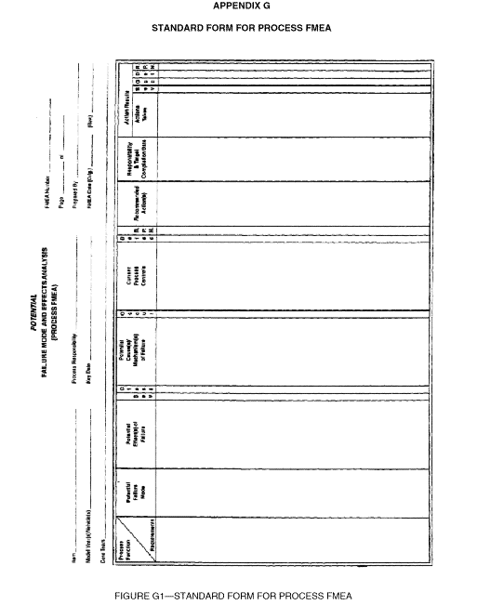FIGURE 4 , scanned image, figure to be updated
Add to heading:
Prevention
Detection
Model year/program
instead of vehicle?
Model year/program
instead of vehicle?
Model year/program
instead of vehicle?
Add Model Year/Program
and delete vehicle
SECTION 4
Potential Failure Mode and Effects Analysis in Manufacturing and Assembly Processes (Process FMEA)

4. Potential Failure Mode and Effects Analysis in Manufacturing and Assembly Processes (Process FMEA)

4.1 Introduction—A Process potential FMEA is an analytical technique utilized by a Manufacturing/Assembly Responsible Engineer/Team as a means to assure that, to the extent possible, potential failure modes and their associated causes/mechanisms have been considered and addressed. In its most rigorous form, an FMEA is a summary of the engineer's/team's thoughts (including an analysis of items that could go wrong based on experience) as a process is developed. This systematic approach parallels and formalizes the mental discipline that an engineer normally goes through in any manufacturing planning process.

The Process potential FMEA:

- Identifies the process functions and requirements
- Identifies potential product and process related failure modes.
- Assesses the potential customer effects of the failures.
- Identifies the potential manufacturing or assembly process causes and identifies process variables on which to focus controls for occurrence reduction or detection of the failure conditions.
- Identifies process variables on which to focus process controls.
- Develops a ranked list of potential failure modes, thus establishing a priority system for preventive/corrective action considerations.
- Documents the results of the manufacturing or assembly process.

4.1.1 CUSTOMER DEFINED—The definition of "CUSTOMER" for a Process potential FMEA should normally be seen as the "END USER." However, customer can also be a subsequent or downstream manufacturing or assembly operation, a service operation, as well as government regulations.
.

4.1.2 TEAM EFFORT—During the initial Process potential FMEA development, the responsible engineer is expected to directly and actively involve representatives from all affected areas. These areas should include, but are not limited to design, assembly, manufacturing, materials, quality, service, and suppliers, as well as the area responsible for the next assembly. The FMEA should be a catalyst to stimulate the interchange of ideas between the areas affected and thus promote a team approach.

Unless the responsible engineer is experienced with FMEA and team facilitation, it
is helpful to have an experienced FMEA Facilitator assist the team in its activities.

The Process FMEA is a living document and should be initiated:
- before or at the feasibility stage,
- prior to tooling for production,
- and take into account all manufacturing operations, from individual components to assemblies.

The PFMEA should be addressed according to the 3 cases outlined is section 1.4.

Early review and analysis of new or revised processes is promoted to anticipate, resolve, or monitor potential process concerns during the manufacturing planning stages of a new model or component program.

The Process FMEA assumes the product as designed will meet the design intent. Potential failure modes which can occur because of a design weakness may be included in a Process FMEA. Their effect and avoidance is covered by the Design FMEA.

The Process FMEA does not rely on product design changes to overcome weaknesses in the process, but does take into consideration a product's design characteristics relative to the planned manufacturing or assembly process to assure that, to the extent possible, the resultant product meets customer needs and expectations.

4.2 Development of a Process FMEA— The process responsible engineer has at his or her disposal a number of documents that will be useful in preparing the Process FMEA. The FMEA begins by developing a listing of what the process is expected to do, and what it is expected not to do, i.e., the process intent.

The Process FMEA can begin with a flow chart of the general process. This flow chart should identify the product/process characteristics associated with each operation. Identification of some product effects from the corresponding Design FMEA, should be included, if available. Copies of the flow chart used in FMEA preparation should accompany the FMEA.

In order to facilitate documentation of the analysis of potential failures and their consequences, a Process FMEA form was developed and is in Appendix F. (See Figure 4.)

An example of a completed form is contained in Appendix H.

4.2.1 (1) FMEA NUMBER—Enter the FMEA document number, which may be used for tracking. (See FIGURE 4.)

4.2.2 (2) ITEM—Enter the name and number of the system, subsystem, or component, for which the process is being analyzed. (See FIGURE 4.)

4.2.3 (3) PROCESS RESPONSIBILITY—Enter the OEM, department, and group. Also include the supplier name if known. (See FIGURE 4.)

4.2.4 (4) PREPARED BY—Enter the name, telephone number, and company of the engineer responsible for preparing the FMEA. (See FIGURE 4.)

4.2.5 (5) MODEL YEAR(S)/PROGRAM(S)—Enter the intended model year(s) and program(s) that will utilize and/or be affected by the design/process being analyzed (if known). (See FIGURE 4.)

4.2.6 (6) KEY DATE—Enter the initial FMEA due date, which should not exceed the scheduled start of production date. (See FIGURE 4.)

4.2.7 (7) FMEA DATE—Enter the date the original FMEA was complied, and the latest revision date. (See FIGURE 4.)

4.2.8 (8) TEAM—List the names of the responsible individuals and departments which have the authority to identify and/or perform tasks. (It is recommended that all team members names, departments, telephone numbers, addresses, etc., be included on a distribution list.) (See FIGURE 4.)

4.2.9 (9) PROCESS FUNCTION/REQUIREMENTS—Enter a simple description of the process or operation being analyzed (e.g., turning, drilling, tapping, welding, assembling). The team should review applicable performance, material, process, environmental, and safety standards. Indicate as concisely as possible the purpose of the process or operation being analyzed, including information about the design (metrics/measurables) describing the system, sub-system or component. Where the process involves numerous operations (e.g., assembling) with different potential modes of failure, it may be desirable to list the operations as separate elements. (See FIGURE 4.)

4.2.10 (10) POTENTIAL FAILURE MODE—Potential Failure Mode is defined as the manner in which the process could potentially fail to meet the process requirements and/or design intent as described in the process function/requirements column. It is a description of the nonconformance at that specific operation. It can be a cause associated with a potential failure mode in a subsequent (downstream) operation or an effect associated with a potential failure in a previous (upstream) operation. However, in preparation of the FMEA, the assumption may be made that the incoming part(s)/ material(s) are correct. Exception can be made by the FMEA team where historical data indicates deficiencies in incoming part quality. (See FIGURE 4.)

List each potential failure mode for the particular operation in terms of a component, subsystem, system, or process characteristic. The assumption is made that the failure could occur, but may not necessarily occur. The process engineer/team should be able to pose and answer the following questions:

a. How can the process/part fail to meet specifications?
b. Regardless of engineering specifications, what would a customer (end user,
subsequent operations, or service) consider objectionable?

A comparison of similar processes and a review of customer (end user and subsequent operation) claims relating to similar components is a recommended starting point. In addition a knowledge of the purpose of the design is necessary. Typical failure modes could be, but are not limited to:

Bent Burred Hole off-location
Cracked Hole too shallow Hole missing
Handling damage Dirty Hole too deep
Surface too rough Deformed Surface too smooth
Open Circuited Short Circuited

4.2.11 (11) POTENTIAL EFFECT(S) OF FAILURE—Potential Effects of Failure are defined as the effects of the failure mode on the customer(s). (See FIGURE 4 and Section 4.1.1.)

Describe the effects of the failure in terms of what the customer might notice or experience, remembering that the customer may be an internal customer as well as the ultimate end user. State clearly if the function could impact safety or noncompliance to regulations. The customer(s) in this context could be the next operation, subsequent operations or locations, the dealer, and/or the vehicle owner. Each must be considered when assessing the potential effect of a failure.

For the End User, the effects should always be stated in terms of product or system performance, such as:

Noise Rough Erratic Operation Excessive Effort
Inoperative Unpleasant Odor Unstable Operation Impaired
Draft Intermittent Operation Poor Appearance
Vehicle Control Impaired
Scrap Rework/Repairs Customer Dissatisfaction Leaks

If the customer is the next operation or subsequent operation(s)/location(s), the effects should be stated in terms of process/operation performance, such as:

Can not fasten Does not fit Can not bore/tap Does not connect
Can not mount Does not match Can not face
Damages equipment Endangers operator Excessive tool wear

- (12) SEVERITY(S)—Severity is the rank associated with the most serious effect from the previous column. Severity is a relative ranking, within the scope of the individual FMEA. A reduction in Severity Ranking index can be effected through a design change to
system, sub-system or component, or a redesign of the process. (See FIGURE 4.)

If the customer affected by a failure mode is the manufacturing or assembly plant or
the product user, assessing the severity may lie outside the immediate process engineer's/team's field of experience or knowledge. In these cases, the design FMEA,
design engineer, and/or subsequent manufacturing or assembly plant process engineer,
should be consulted.

- Suggested Evaluation Criteria—The team should agree on an evaluation criteria and ranking system, which is consistent, even if modified for individual process analysis. (See Table 4.) ,

Severity should be estimated using the following table as a guideline:

Notes - It is not recommended to modify criteria for ranking values of 9 & 10. Failure Modes with rank Severity 1, should not be analyzed further.

Table 4 – Suggested PFMEA Severity Evaluation Criteria

Effect | Criteria: Severity of Effect  This ranking results when a potential failure mode results in a final customer and/or a manufacturing/  assembly plant defect. The final customer should always be considered first. If both occur, use the higher of the two severities. |  | Ranking
 | (Customer effect) | (Manufacturing/ Assembly effect)
Hazardous  without warning | Very high severity ranking when a potential failure mode affects safe vehicle operation and/or involves noncompliance with government regulation without warning. | Or may endanger operator ( machine or assembly) without warning. | 10
Hazardous  with warning | Very high severity ranking when a potential failure mode affects safe vehicle operation and/or involves noncompliance with government regulation with warning. | Or may endanger operator (machine or assembly) with warning. | 9
Very High | Vehicle/item inoperable (loss of primary function). | Or 100% of product may have to be scrapped, or vehicle/item repaired in repair department with a repair time greater than one hour. | 8
High | Vehicle/Item operable but at a reduced level of performance. Customer very dissatisfied. | Or product may have to be sorted and a portion (less than 100%) scrapped, or vehicle/item repaired in repair department with a repair time between half an hour and an hour. | 7
Moderate | Vehicle/Item operable but Comfort/Convenience item(s) inoperable. Customer dissatisfied. | Or a portion (less than 100%) of the product may have to scrapped with no sorting, or vehicle/item repaired in repair department with a repair time less than half an hour. | 6
Low | Vehicle/Item operable but Comfort/Convenience item(s) operable at a reduced level of performance. Customer somewhat dissatisfied. | Or 100% of product may have to be reworked, or vehicle/item repaired off-line but does not go to repair department. | 5
Very Low | Fit & finish/Squeak & rattle item does not conform. Defect noticed by most customers (greater than 75%). | Or the product may have to be sorted, with no scrap, and a portion (less than 100%) reworked. | 4
Minor | Fit & finish/Squeak & rattle item does not conform. Defect noticed by 50 percent of customers. | Or a portion (less than 100%) of the product may have to be reworked, with no scrap, on-line but out-of-station. | 3
Very Minor | Fit & finish/Squeak & rattle item does not conform. Defect noticed by discriminating customers (less than 25 percent). | Or a portion (less than 100%) of the product may have to be reworked, with no scrap, on-line but in-station. | 2
None | No discernible effect. | Or slight inconvenience to operation or operator, or no effect. | 1

4.2.13 (13) CLASSIFICATION—This column may be used to classify any special product or
process characteristics (e.g., critical, key, major, significant) for components,
subsystems, or systems that may require additional process controls. (See FIGURE 4)

This column may also be used to highlight high priority failure modes for engineering assessment.

If a classification is identified in the Process FMEA, notify the design responsible engineer since this may affect the engineering documents concerning control item identification.

Special Product or Process Characteristic symbols and their usage is directed by specific company policy and is not standardized in this recommended practice.

4.2.14 (14) POTENTIAL CAUSE(S)/MECHANISM(S) OF FAILURE—Potential Cause of Failure is defined as how the failure could occur, described in terms of something that can be corrected or can be controlled. (See FIGURE 4.)

List, to the extent possible, every failure cause assignable to each potential failure mode. If a cause is exclusive to the failure mode, i.e., if correcting the cause has a direct impact on the failure mode, then this portion of the FMEA thought process is completed. Many causes, however, are not mutually exclusive, and to correct or control the cause, a design of experiments, for example, may be considered to determine which root causes are the major contributors and which can be most easily controlled. The causes should be described so that remedial efforts can be aimed at those causes which are pertinent. Typical failure causes may include, but are not limited to:

Improper torque - over, under Improper weld - current, time, pressure
Inaccurate gauging Improper heat treat - time, temperature
Inadequate gating/venting Inadequate or no lubrication
Part missing or mislocated Worn locator
Worn tool Chip on locator
Broken tool Improper machine setup
Improper programming
Only specific errors or malfunctions (e.g., operator fails to install seal) should be listed; ambiguous phrases (e.g., operator error, machine malfunction) should not be used.

For Severity rankings 9 or 10, it is recommended that causes be taken to a root cause level and be entered on the form in this column.

4.2.15 (15) OCCURRENCE (O)—Occurrence is the likelihood that a specific cause/mechanism (listed in the previous column) will occur. The likelihood of occurrence ranking number has a relative meaning rather than an absolute value. Preventing or controlling the causes/mechanisms of the failure mode through a design or process change is the only way a reduction in the occurrence ranking can be effected. (See FIGURE 4.)

Estimate the likelihood of occurrence of potential failure cause/mechanism on
a "1" to "10" scale.

A consistent occurrence ranking system should be used to ensure continuity. The occurrence ranking number is a relative rating within the scope of the FMEA and may not reflect the actual likelihood of occurrence.

The "Possible Failure Rates" are based on the number of failures which are anticipated during the process execution. If available from a similar process, statistical data should be used to determine the occurrence ranking. In all other cases, a subjective assessment can be made by utilizing the word descriptions in the left column of the table, along with any historical data available for similar processes.

- .1 Suggested Evaluation Criteria—The team should agree on an evaluation criteria
and ranking system, which is consistent, even if modified for individual process
analysis. (See Table 5.)

Occurrence should be estimated using the following table as a guideline:

NOTE - The ranking value of 1 is reserved for “Remote: Failure Is unlikely”.

Table 5 – Suggested PFMEA Occurrence Evaluation Criteria

Probability of Failure | Likely Failure Rates | Ranking
Very High: Persistent failures | ≥100 per thousand pieces | 10
 | 50 per thousand pieces | 9
High: Frequent  failures | 20 per thousand pieces | 8
 | 10 per thousand pieces | 7
Moderate: Occasional failures | 5 per thousand pieces | 6
 | 2 per thousand pieces | 5
 | 1 per thousand pieces | 4
Low: Relatively few failures | 0.5 per thousand pieces | 3
 | 0.1 per thousand pieces | 2
Remote: Failure is unlikely | ≤ 0.01 per thousand pieces | 1

4.2.16 (16) CURRENT PROCESS CONTROLS—Current Process Controls are descriptions of the controls that either prevent to the extent possible the failure mode/cause from occurring or detect the failure mode or cause should it occur. These controls can be process controls such as error/mistake proofing or Statistical Process Control (SPC), or can be post-process evaluation. The evaluation may occur at the subject operation or at subsequent operations. (See FIGURE 4.)

There are two types of Process Controls/features to consider:

Type 1. Prevention: Prevent the cause/mechanism or failure mode/effect from
occurring,or reduce their rate of occurrence,
Type 2. Detection: Detect the cause/mechanism or failure mode, and lead to
corrective action(s).

The preferred approach is to first use type (1) controls if possible. The initial occurrence rankings will be affected by the type (1) controls provided they are integrated as part of the process intent. The initial detection rankings will be based on the type (2) current process controls, planned for production operation.

4.2.17 (17) DETECTION (D)— Detection is the rank associated with the best type (2) process
control listed in the previous column. Detection is a relative ranking, within the
scope of the individual FMEA. In order to achieve a lower ranking, generally the
planned process control has to be improved. (See FIGURE 4)

Assume the failure has occurred and then assess the capabilities of all "Current Process Controls" to prevent shipment of the part having this failure mode or defect. Do not automatically presume that the detection ranking is low because the occurrence is low (e.g., when Control Charts are used), but do assess the ability of the process controls to detect low frequency failure modes or prevent them from going further in the process.

Random quality checks are unlikely to detect the existence of an isolated defect and
should not influence the detection ranking. Sampling done on a statistical basis is a
valid detection control.

4.2.17.1 Suggested Evaluation Criteria—The team should agree on an evaluation criteria and ranking system, which is consistent, even if modified for individual product analysis. (See Table 6.)

Detection should be estimated using the following table as a guideline:

NOTE - The ranking value of 1 is reserved for “Almost Certain.”

Table 6 – Proposed PFMEA Detection Evaluation Criteria
Inspection Types:

Detection | Criteria | 1 | 2 | 3 | Suggested Range of Detection Methods | Ranking
Almost Impossible | Absolute certainty of non-detection. |  |  |  | Cannot detect or is not checked. | 10
Very Remote | Controls will probably not detect. |  |  |  | Control is achieved with indirect or random checks only. | 9
Remote | Controls have poor chance of detection. |  |  |  | Control is achieved with visual inspection only. | 8
Very Low | Controls have poor chance of detection. |  |  |  | Control is achieved with double visual inspection only. | 7
Low | Controls may detect. |  |  |  | Control is achieved with charting methods, such as SPC {Statistical Process Control}. | 6
Moderate | Controls may detect. |  |  |  | Control is based on variable gauging after parts have left the station, OR Go/No Go gauging performed on 100% of the parts after parts have left the station. | 5
Moderately High | Controls have a good chance to detect. |  |  |  | Error detection in subsequent operations, OR gauging performed on setup and first-piece check. | 4
High | Controls have a good chance to detect. |  |  |  | Error detection in-station, OR error detection in subsequent operations by multiple layers of acceptance: supply, select, install, verify. Can not accept discrepant part. | 3
Very High | Controls almost certain to detect. |  |  |  | Error detection in-station (automatic gauging with automatic stop feature). Can not pass discrepant part. | 2
Very High | Controls certain to detect. |  |  |  | Discrepant parts can not be made because item has been error proofed by process/product design. | 1

Inspection Types:
- Error Proofed
- Gauging
- Manual Inspection

4.2.18 (18) RISK PRIORITY NUMBER (RPN)—The Risk Priority Number is the product of the
Severity (S), Occurrence (O), and Detection (D) ranking. (See FIGURE 4)

RPN = (S) x (O) x (D) (Equation 2)

Within the scope of the individual FMEA, this value (between “1” and “1000”) can be used to rank order the concerns in the process (e.g., in Pareto fashion).

4.2.19 (19) RECOMMENDED ACTION(s)- Engineering assessment for corrective action should be first directed at high severity, high RPN and other items designated by the team. The intent of any recommended action is to reduce rankings, in the following preference order: severity, occurrence, and detection rankings. (See FIGURE 4).

In general practice when the severity is “9” or “10”, special attention must be given to assure that the risk is addressed through existing design actions/controls or process preventive/corrective action(s), regardless of the RPN. In all cases where the effect of an identified potential failure mode could be a hazard to manufacturing/ assembly personnel, preventive/corrective actions should be taken to avoid the failure mode by eliminating or controlling the cause(s), or appropriate operator protection should be specified.

After special attention has been given to Severity(s) of 9 or 10, the team then addresses other Failure Modes, with the intent of reducing Severity, then Occurrence and then Detection.

Actions such as, but not limited to, the following should be considered:

- To reduce the probability of occurrence, process and/or design revisions are required. An action-oriented study of the process using statistical methods could be implemented with an ongoing feedback of information to the appropriate operations for continuous improvement and defect prevention.

- Only a design and/or process revision can bring about a reduction in the severity ranking.

- To increase the probability of detection, process and/or design revisions are required. Generally, improving detection controls is costly and ineffective for quality improvements. Increasing quality controls inspection frequency is not positive preventive/corrective action and should only be utilized as a temporary measure, permanent preventive/corrective action is required. In some cases, a design change to a specific part may be required to assist in the detection. Changes to the current control system may be implemented to increase this probability.

Emphasis must, however, be placed on preventing defects (i.e., reducing the occurrence) rather than detecting them. An example would be the use of Statistical Process Control and process improvement rather than random quality checks or associated inspection.

If engineering assessment leads to no recommended actions for a specific failure mode/cause/control combination, indicate this by entering a "NONE" in this column.

4.2.20 (20) RESPONSIBILITY (FOR THE RECOMMENDED ACTION)—Enter the individual responsible for the recommended action, and the target completion date. (See FIGURE 4.)

4.2.21 (21) ACTIONS TAKEN—After an action has been implemented, enter a brief description of the action and effective date. (See Figure 4.)

4.2.22 (22) Revised Ratings—After the preventive/corrective action has been identified, estimate and record the resulting severity, occurrence, and detection rankings. Calculate and record the resulting RPN. If no actions are taken, leave the related ranking columns blank. (See Figure 4.)

All revised ratings should be reviewed and if further action is considered necessary, repeat 4.2.19 through 4.2.22.

NEW SECTION : Section 5

FMEA APPLICATIONS

MACHINERY FMEA Application Example

FIGURE 5--MACHINERY FMEA FORM

The figure above should be rotated 90 degrees CCW.

- Potential Failure Mode and Effects Analysis for Machinery
(Machinery FMEA)

5.1 Introduction – A Machinery FMEA (MFMEA) for tooling and equipment is an analytical technique utilized primarily by a machinery responsible engineering team. The purpose of the FMEA is to assure that potential failure modes and their associated causes/mechanisms have been addressed. In its most rigorous form, an FMEA is a summary of the team’s thoughts (including analysis of items that could go wrong based on experience and past concerns) as the machinery is designed. The systematic approach parallels, formalizes and documents the mental disciplines that an engineer/team normally goes through in any design/development process.

The Machinery Potential FMEA supports the design process in reducing risk of failures by:

- Aiding in the objective evaluation of equipment functions, design requirements and design alternatives.
- Increasing the probability that potential failure modes and their effects on the machinery have been considered in the design and development process.
- Providing additional information to aid in the planning of thorough and efficient design, validation and development programs.
- Developing a ranked list of potential failure modes ranked according to their effect on the “customer”, thus establishing a priority system for design improvements, development and validation testing/analysis.
- Providing future reference, e.g. lessons learned to aid in analyzing field concerns, evaluating design changes and developing advanced machinery designs.

When fully implemented, the MFMEA discipline can be performed on new, modified or carry-over designs in new applications or environments. An engineer from the responsible design source should initiate the MFMEA process, which for a proprietary design, may be the supplier.

5.1.1 Customer Defined – The definition of “Customer” for a MFMEA is the “Plant” where the machinery is to be installed for production. The word “Plant” refers to plant engineers, maintenance, production and other plant support personnel.

5.1.2 Team Effort – During the MFMEA process, the machinery responsible engineer is expected to actively involve representatives from all affected areas. These areas should include, but are not limited to production, manufacturing engineering, safety, quality, suppliers and product engineering. The MFMEA should be a catalyst to stimulate the interchange of ideas between activities affected and thus promotes a team approach. In addition, for any commercial “Catalog” components, the responsible representative from the component supplier should be consulted as required.

Unless the responsible engineer is experienced with FMEA and team facilitation, it
is helpful to have an experienced FMEA Facilitator assist the team in its activities.

The Machine FMEA is a living document and should:
- be initiated during design concept development.,
- be continually updated as changes occur or additional information is obtained throughout the phases of machinery development,
- should be completed before engineering release for construction.

The MFMEA analyzes functions, design requirements, needs and assumes the machinery will be built to specification. The focus of the MFMEA is to eliminate potential failures by removing design weaknesses before the machinery is built as opposed to relying on machinery controls and/or preventive maintenance to reduce the occurrence of the failures.

5.2 Development of a Machinery FMEA – The machinery design responsible engineer has at his/her disposal a number of formal and informal documents that will be useful in the preparation of the Machinery FMEA. The process of preparing the MFMEA begins with the full understanding of what the machinery is expected to do or not to do, in a given environment, under stated conditions, and for a defined period of time. These expectations may be determined from sources such as the Reliability & Maintainability specification statement, design requirements, performance reports, maintenance history, program objectives, and federal or local regulatory requirements.

A Machine FMEA should begin by prioritizing the sub-system improvements necessary in order to meet the overall system expectations.

A Machine FMEA can begin with a block diagram for the system or subsystem being analyzed. An example of the block diagram is shown in Appendix C.

In order to facilitate documentation of the Machinery FMEA a form is available in Appendix I.

An example of a completed form is contained in Appendix K.

An example of a welding station with five subsystems is shown in series, as illustrated in Figure 6. All of them have to function correctly for the welding station to operate at the required rate. In order to increase system reliability improvements should focus on subsystems with lower reliability’s or higher failure rates. In the example shown below, improvements should focus on robot end effector.

Panel View
Failure Rate:
0.0001/hour
Programmable Controller Failure Rate:
0.008/hour
Pedestal Welder Failure Rate:
0.02/hour
Robot End Effector Failure Rate:
0.125/hour
Accumulator Failure Rate:
0.100/hour

Figure 6 - Welding Station Series System

5.2.1 FMEA Number – Enter the FMEA document number, which may be used for tracking.
(See Figure 5).

5.2.2 Machine/System Name – The name of the system being analyzed along with the
appropriate level of analysis. (See Figure 5).

5.2.2.1 Subsystem – Enter the name and description of the sub-system being analyzed. The
identification of a subsystem will determine the boundaries for analysis. (See Figure 5).

A subsystem is an organized composition of components, parts, details, fixtures or tooling which collectively support the performance of the design intent or engineering requirement (i.e., hydraulic, electrical, controls, automatic loader, conveyor, station etc.,).

5.2.3 Design Responsibility – The OEM, department, group and the supplier name as applicable. (See Figure 5).

5.2.4 Prepared By – Enter the name, telephone number, and the company of the engineer responsible for preparing the MFMEA document. (See Figure 5).

5.2.5 Model Year(s) / Plant(s) – Enter the intended model year(s) and plants that will utilize and/or be affected by the machinery being analyzed. (See Figure 5).

5.2.6 Key Date – Enter the initial MFMEA due date, which should not exceed the scheduled engineering release date for construction. (See Figure 5).

5.2.7 FMEA Date – Enter the date the original MFMEA was compiled, and the latest revision date.
(See Figure 5).

5.2.8 Team – List the names of the lead individuals and departments, which are responsible
for the decisions and actions taken through the MFMEA. (It is recommended that all team members’ names, departments, telephone numbers addresses, etc. be included on the distribution list.) (See Figure 5).

5.2.9 Function / Requirement – The function of the subsystem being analyzed along with performance requirements. (See Figure 5). Include information (metrics/measurables) regarding the environment in which the subsystem operates. If the subsystem has more than one function with different potential modes of failure, list all the functions separately.

Examples:

To pump sealant to panel at the rate of X cubic centimeters per minute
To pump coolant to work piece at not less than X gallons per minute.
To achieve a torque of X N-m in Y seconds.
To ramp up to X degree Celsius in Y seconds and maintain temperature for Z seconds.

5.2.10 Potential Failure Mode – Potential Failure Mode is defined as the manner in which the machinery could potentially fail to meet or deliver its intended function described in the sub-system/functions, requirements column (i.e., intended function fails). For every potential failure an action is required is required to bring the machinery back to its production capability.
(See Figure 5)

List each potential failure mode associated with the particular item and item function. The assumption is made that the failure could occur, but may not necessarily occur. A recommended starting point is a review of machinery supplier correction action reports, lessons learned documents, machinery down time logs and group brainstorming.

Potential failure modes that could only occur under certain operating conditions )i.e., temperature extremes, high humidity, external shock/vibration) and under certain usage conditions (increased line rate) should be considered.

Examples:

Failure to operate at prescribed time Failure to stop operating at a prescribed time
Intermittent operation Degraded output
Inadequate torque Loss of output during operation
Partial or complete loss of function

- Potential Effects of Failure – The effects should be stated in terms of a specific system,
sub-system being analyzed and the impact of the failure mode on upstream and
downstream processes.

State clearly if the function could impact safety or noncompliance to regulations. The effects should always be stated in terms of the specific system, subsystem, or component being analyzed. List all effects and rank the most severe effect. Typical failure effects could be, but are not limited to:

Machinery breakdowns Increased cycle time
Setup and adjustment Impaired performance
Non-conforming parts

5.2.12 Severity – Severity is the rank associated with the most serious effect from the previous
column. Severity is a relative ranking, within the scope of the individual FMEA.
A reduction in Severity Ranking index can be effected only through a machinery
design change. Severity should be estimated using the following table:

5.2.12.1 Suggested Evaluation Criteria – The team should agree on an evaluation criteria and ranking
system, which is consistent, even if modified for an individual system. (See Table 7.)

Notes - It is not recommended to modify criteria for ranking values of 9 ‘s & 10’s. Failure Modes with rank Severity 1, should not be analyzed further.

Table 7: Suggested Severity Evaluation Criteria
Effect | Severity of Effect | Ranking
Hazardous – Without Warning | Very high severity ranking – Affects operator, plant or maintenance personnel, safety and or affects non-compliance with government regulations, without warning. | 10
Hazardous – With Warning | High severity ranking – Affects operator, plant or maintenance personnel, safety and/or affects non-compliance with government regulations with warning. | 9
Very High | Downtime of more than 8 hours or the production of defective parts for more than 4 hours. | 8
High | Downtime of between 4 and 8 hours or the production of defective parts for between 2 & 4 hours. | 7
Moderate | Downtime of between 1 and 4 hours or the production of defective parts for between 1 and 2 hours. | 6
Low | Downtime of between 30 minutes and 1 hour or the production of defective parts for up to 1 hour. | 5
Very Low | Downtime of between 10 and 30 minutes but no production of defective parts. | 4
Minor | Downtime of up to 10 minutes but no production of defective parts | 3
Very Minor | Process parameter variability not within specification limits. Adjustment or other process controls need to be taken during production. No downtime and no production of defective parts. | 2
None | Process parameter variability within specification limits. Adjustment or other process controls can be taken or during normal maintenance | 1

5.2.13 Classification – Optional column, may be used to highlight failures with a high severity
ranking or other company mandated usage.

- Potential Causes/Mechanism’s of Failure – Potential Cause of Failure is defined as
the machinery design weakness or machine process variation that results in a failure.
(See FIGURE 5.)

List, to the extent possible, every potential cause and/or failure mechanism for each failure mode. The cause/mechanism should be listed as concisely and completely as possible so that remedial efforts can be aimed at pertinent causes.

Typical failure causes may include, but are not limited to:

Mis-located parts Component misapplication Over stressing
Contamination Material fatigue Corrosion
Inadequate or no lubrication

Typical failure mechanisms may include, but are not limited to:

Yield Corrosion Fatigue
Creep Abrasion Material instability
Wear

5.2.15 (15) OCCURRENCE (O)—Occurrence is the likelihood that a failure mode will occur within a specific time period. Preventing or controlling (via design change or preventive maintenance) are the only ways to reduce the occurrence rating.

A consistent occurrence ranking system should be use to ensure continuity. The occurrence ranking number is a relative rating within the scope of the FMEA and may not reflect the actual likelihood of occurrence.

- Suggested Evaluation Criteria - The team should agree on evaluation criteria and
ranking system, which is consistent, even if modified for an individual system. (See
Table 8) The following suggested criteria allows for the use of standard operating
time or reliability as a means for determining the occurrence rankings.

- Reliability is the probability that manufacturing machinery/equipment can perform
continuously, without failure, for a specified interval of User’s time when operating
under stated conditions.

- User’s time is the span of time the machinery is required to run without failure (time, cycles,
etc.). The User’s time frame should be defined in terms of an operating pattern that is
important to the user.

NOTE - The ranking value of 1 is reserved for “Remote: Failure Is unlikely”.

Table 8: Suggested Occurrence Evaluation Criteria

Probability  of Failure | Criteria: Possible Number of failures within Hours of operation. | OR | Criteria: The reliability based on the users required time. | Ranking
Failure Occurs every Hour | 1 in 1 |  | R(t) <1 %: MTBF is about 10% of the User’s required time. | 10
Failure occurs every shift | 1 in 8 |  | R(t) = 5%: MTBF is about 30% of User’s required time | 9
Failure occurs every day | 1 in 24 |  | R(t) = 20%: MTBF is about 60% of the User’s required time. | 8
Failure occurs every week | 1 in 80 |  | R(t) = 37%: MTBF is equal to the User’s required time. | 7
Failure occurs every month | 1 in 350 |  | R(t) = 60%: MTBF is 2 times greater than the User’s required time. | 6
Failure occurs every 3 months | 1 in 1000 |  | R(t) = 78%: MTBF is 4 times greater than the User’s required time. | 5
Failure occurs every 6 months | 1 in 2500 |  | R(t) = 85%: MTBF is 6 times greater than the User’s required time | 4
Failure occurs every year | 1 in 5000 |  | R(t) = 90%: MTBF is 10 times greater than the User’s required time. | 3
Failure occurs every 2 years | 1 in 10,000 |  | R(t) = 95%: MTBF is 20 times greater than the User’s required time. | 2
Failure occurs every 5 years | 1 in 25,000 |  | R(t) = 98%: MTBF is 50 times greater than the User’s required time. | 1

Note: The Occurrence table rankings utilizing reliability calculations, as shown in this Section, assumes the machines have a constant failure rate and are repairable. See Appendix J for sample calculations for the Occurrence table.

- Current Design/Machinery Controls – Current Design/Machinery controls are methods, techniques, devices or tests, classified into two types of controls, used to:

Type 1. Prevention: Prevent the cause/mechanism or failure mode/effect from occurring,
or reduce their rate of occurrence,
Type 2. Detection: Detect the cause/mechanism or failure mode, either by analytical or
physical methods, before the item is released to production.

Examples of Design Controls: Examples of Machinery Controls:

Component de-rating Preventative maintenance
Safety margins Machinery diagnostics
Design guidelines Predictive technologies
Standardization Visual management techniques
Robot reach studies Fault sensors
Finite element analysis
Simulations studies

5.2.17 Detection – The assessment of the ability of the current controls to detect the potential
cause or failure mode. Design related controls that detect and/or prevent the potential
failure mode before machinery acceptance by the user will have a low detection ranking
number. Machinery related controls that detect failure modes and causes and prevent
them from occurring during production would have moderate ranking number. Controls
that detect failure modes and causes after they occur will have high ranking numbers.

5.2.17.1Suggested Evaluation Criteria - The team should agree on an evaluation criteria and
ranking system, which is consistent, even if modified for an individual system.

NOTE - The ranking value of 1 is reserved for “Almost Certain.”

Table 9: Suggested Detection Evaluation Criteria
Detection | Criteria | Ranking
Very Low | Design or Machinery Controls cannot detect a potential cause and subsequent failure, or there are no design or machinery controls. | 10
Low | Design or Machinery controls do not prevent the failure from occurring. Machinery controls will isolate the cause and subsequent failure mode after the failure has occurred. | 7
Medium | Design controls may detect a potential cause and subsequent failure mode. Machinery controls will provide an indicator of imminent failure. | 5
High | Design controls may detect a potential cause and subsequent failure mode. Machinery controls will prevent an imminent failure and isolate the cause. | 3
Very High | Design controls almost certainly detect a potential cause and subsequent failure mode, machinery controls not required. | 1

Teams are free to use rankings of 2,4,6,8 & 9 as needed in addition to those listed above.

5.2.18 Risk Priority Number – The Risk Priority Number is the product
of the Severity (S), Occurrence (O), and Detection (D) ranking. (See FIGURE 2).

RPN = (S) x (O) x (D) (Equation 3)

Within the scope of the individual FMEA, this value (between “1” and
“1000”) can be used to rank order the concerns in the design (e.g., in Pareto
fashion).

5.2.19 (19) RECOMMENDED ACTION(s)- Engineering assessment for corrective action should be first directed at high severity, high RPN and other items designated by the team. The intent of any recommended action is to reduce rankings, in the following preference order: severity, occurrence, and detection rankings. (See FIGURE 5).

In general practice when the severity is a “9” or “10”), special attention must be given to assure that the risk is addressed through existing design controls or preventative or corrective action(s), regardless of the RPN. In all cases where the effect of an identified potential failure mode could be a hazard to manufacturing/ assembly personnel, preventive/corrective actions should be taken to avoid the failure mode by eliminating or controlling the cause(s), or appropriate operator protection should be specified.

After special attention has been given to Severity(s) of 9 or 10, the team then addresses other Failure Modes, with the intent of reducing Severity, then Occurrence and then Detection.

The primary objective of recommended actions is to reduce risks and increase customer satisfaction by improving the design.

Only a design revision can bring about a reduction in the severity ranking. A reduction in the occurrence ranking can be effected only by removing or controlling one or more of the causes/mechanisms of the failure mode through a design revision. An increase in design validation/verification actions will result in a reduction in the detection ranking only. Increasing the design validation/verification actions is a less desirable engineering action since it does not address the severity or occurrence of the failure mode.

If engineering assessment leads to no recommended actions for a specific failure mode/cause/control combination, indicate this by entering a "NONE" in this column.

5.2.20 Responsibility (For the Recommended Action) – Enter the organization and/or individual responsible for the recommended action and its target completion date. (See Figure 5)

- Actions Taken – After an action has been implemented, enter a brief description of the
actual action taken and its effective date. (See Figure 5)

5.2.22 Revised Ratings – After the preventive/corrective action has been identified, estimate and record the resulting severity, occurrence, and detection rankings. Calculate and record the resulting RPN. If no actions are taken, leave the related ranking columns blank.

All revised ratings should be reviewed and if further action is considered necessary, repeat 5.2.19 through 5.2.22.

5.2.23 Follow-Up – The design engineer is responsible for assuring that all actions
recommended have been implemented or adequately addressed. The MFMEA is a
living document and should always reflect the latest machinery design level, as well as
the latest relevant actions, including those occurring after the start of production.

In order to facilitate documentation of the analysis of potential failures and their consequences, a sample form is provided in Figure I.

APPENDIX A
DESIGN FMEA QUALITY OBJECTIVES

1. DESIGN IMPROVEMENTS
The FMEA drives Design Improvements as the primary objective.

2. HIGH RISK FAILURE MODES
The FMEA addresses all high risk Failure Modes, as identified by the FMEA team, with executable Action Plans. All other failure modes are considered.

3. A/D/V OR DVP&R PLANS
The Analysis/Development/Validation (A/D/V), and/or Design Verification Plans comprehends the failure modes from the Design FMEA.

4. INTERFACES
The FMEA scope includes integration and interface failure modes in both block diagram and analysis.

5. LESSONS LEARNED
The FMEA considers all major “lessons learned” (such as high warranty, campaigns, etc.) as input to failure mode identification.

6. SPECIAL OR KEY CHARACTERISTICS
The FMEA identifies appropriate Key Characteristics candidates, as input to the Key Characteristics selection process.

7. TIMING
The FMEA is completed during the “Window of opportunity” where it could most efficiently impact the product design.

8. TEAM
The right people participate as part of the FMEA team throughout the analysis, and are adequately trained in the procedure. As appropriate, a facilitator should be utilized.

9. DOCUMENTATION
The FMEA document is completely filled out “by the book”, including “Action Taken” and new RPN values.

10. TIME USAGE
Time spent by the FMEA team, as early as possible, is an effective & efficient use of time, with a value-added result. This assumes Recommended Actions are identified as required and the actions are implemented.

APPENDIX B
PROCESS FMEA QUALITY OBJECTIVES

1. PROCESS IMPROVEMENTS
The FMEA drives Process Improvements as the primary objective, with an emphasis on Error/Mistake Proofing solutions.

2. HIGH RISK FAILURE MODES
The FMEA addresses all high risk Failure Modes, as identified by the FMEA team, with executable Action Plans. All other failure modes are considered.

3. PROCESS CONTROL PLAN
The Process Control Plan comprehends the failure modes from the Process FMEA.

4. INTEGRATION
The Process FMEA is integrated and consistent with the Process Flow Diagram and the Process Control Plan. The Process FMEA considers the Design FMEA as part of its analysis.

5. LESSONS LEARNED
The FMEA considers all major “lessons learned” (such as high warranty, campaigns, etc.) as input to failure mode identification.

6. SPECIAL OR KEY CHARACTERISICS
The FMEA identifies appropriate Key Characteristics candidates, as input to the Key Characteristics selection process.

7. TIMING
The FMEA is completed during the “Window of opportunity” where it could best impact the design of product or process.

8. TEAM
The right people participate as part of the FMEA team throughout the analysis, and are adequately trained in the procedure. As appropriate, a facilitator should be utilized

9. DOCUMENTATION
The FMEA document is completely filled out “by the book”, including “Action Taken” and new RPN.

10. TIME USAGE
Time spent by the FMEA team, as early as possible, is an effective & efficient use of time, with a value-added result. This assumes Recommended Actions are identified as required and the actions are implemented.
APPENDIX C DESIGN FMEA BLOCK DIAGRAM EXAMPLE 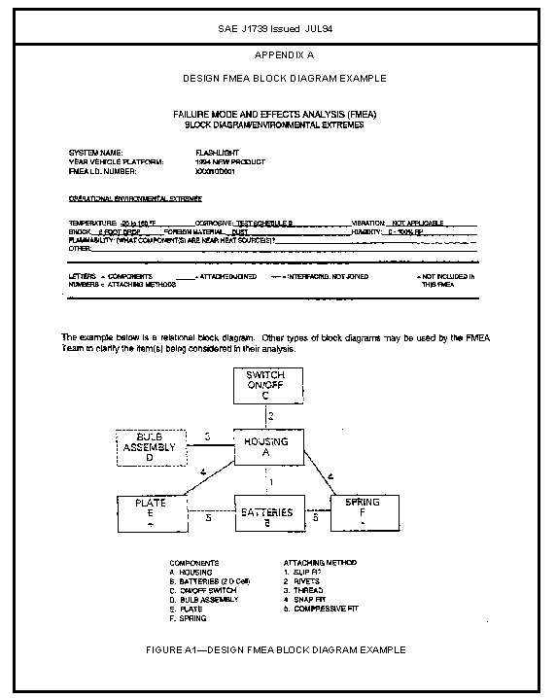
APPENDIX DSTANDARD FORM FOR DESIGN FMEAFIGURE D—STANDARD FORM FOR DESIGN FMEA 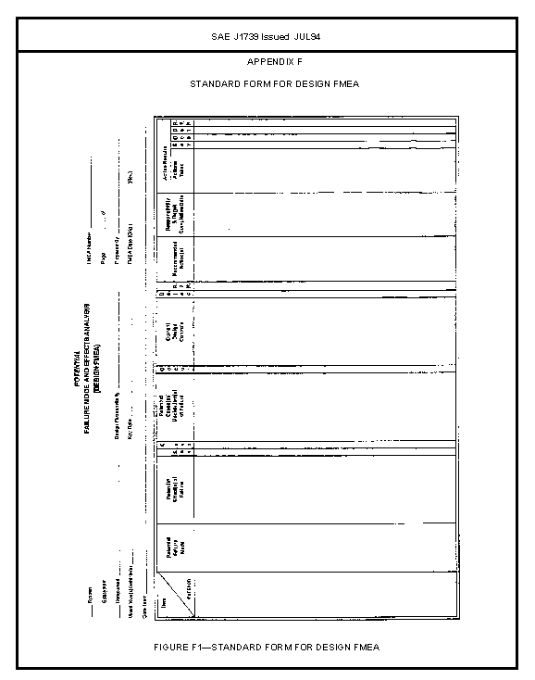
Add: Prevention
Detection to header
Add Model Year / and Program and delete Vehicle

APPENDIX E DESIGN FMEA EXAMPLE FIGURE E—DESIGN FMEA 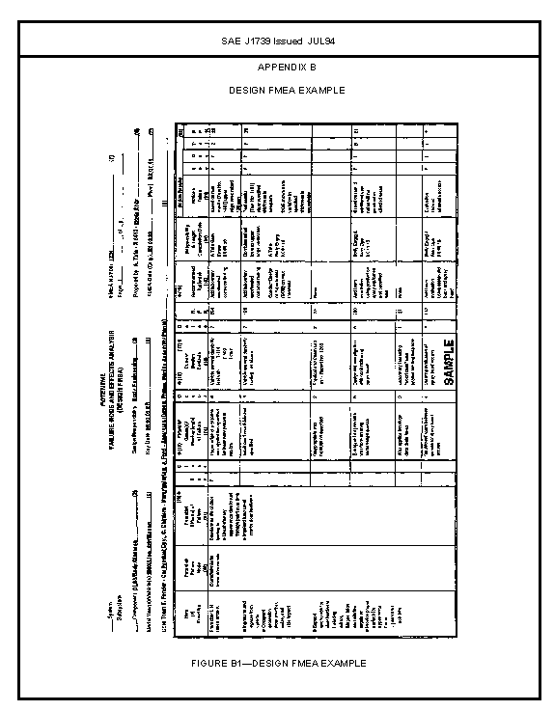
Add: Prevention
Detection to header
Add Model Year / and Program and delete Vehicle

Appendix F: System FMEA

Section 3.2.2 discusses the scope of System, Sub-System, and Component FMEA's. To help illustrate the meaning of these FMEA's, two examples have been constructed below in Figure F1 (for Interfaces and Interactions) and in Figure F2 (for Item, Function, and Failure Modes).

Example 1: Interfaces and Interactions

Subsystem A
Subsystem B
Subsystem C
Subsystem D

System

Environment

Figure F1, Interfaces and Interactions

It is the responsibility of the FMEA Team to specify the scope of their respective FMEA's. The example in Figure F1 shows that the Team has specified Subsystems A, B, C, and D along with the surrounding environment as comprising the System that must be considered while completing the System FMEA.

INTERFACES: SUBSYSTEMS ARE DIRECTLY CONNECTED VIA INTERFACES.
In Figure F1, interfaces between subsystems are shown where Subsystem A touches
(connects with) Subsystem B, B touches C, C touches D, A touches D, and B
touches D. It should be noted that the Environment also touches each of the
subsystems listed in Figure F1, which requires that the 'Environmental Interfaces'
be considered when completing the FMEA.
NOTE: Each Subsystem FMEA should have its Interfaces included in its
respective Subsystem FMEA.

INTERACTIONS: A CHANGE IN ONE SUBSYSTEM MIGHT CAUSE A CHANGE
IN ANOTHER SUBSYSTEM.
In Figure F1, interactions between subsystems can occur between any of the
interfacing systems (e.g., Subsystem A heats up resulting in Subsystem D
and Subsystem B also gaining heat through the respective interfaces, as
well as the Subsystem A giving off heat to the environment). Interactions
might also occur between 'non-contacting' systems via transfer through the
'environment' (e.g., if the environment is composed of high humidity and
Subsystems A and C are dissimilar metals separated by a non-metal
composing Subsystem B, Subsystems A and C can still have an electrolytic
reaction due to the moisture from the environment). Thus, interactions
between non-contacting subsystems can be relatively difficult to predict, but
are important and should be considered.

Example 2: Items, Functions, and Failure Modes

Figure F2 (see next page) describes a method of showing the Items, Functions, and Failure Modes in a 'tree arrangement' that can assist the team in visualizing the System, Subsystems, and Components.
At the System Level, the descriptions will tend to be much more general than for the Subsytems and Components (Components will usually have the most specific descriptions).

The 'tree arrangement' is arranged as follows for the System, Subsystem, and Components:

ITEM

Design Objectives (a statement of design objectives is often helpful)

--FUNCTION 1
•FAILURE MODE A
•FAILURE MODE B
• etc.....

--FUNCTION 2
•FAILURE MODE A
•FAILURE MODE B
• etc.....

-- etc.....

System Level
Subsystem Level
Component Level
Design Objectives:
1) minimum 3000 hours of riding
without need for maintenance and
10,000 hours of riding for design
life.
2) accommodates male adults
comfortably to the 99.5th percentile
3) … etc. …

Function:
ease of use
Potential Failure Mode(s):
. difficult to steer
. difficult to pedal
Function:
provide reliable transportation
Potential Failure Mode(s):
. chain breaks frequently
. Tires require frequent maintenance
.
Function:
provide comfortable transportation
Potential Failure Mode(s):
. seating position is not comfortable
. awkward riding position - handle
bars too far forward
.
Bicycle
Frame
Upper Frame Tube
Function:
provides stable attachment for seat
support
Potential Failure Mode(s):
. structural failure of seat support
. excessive deflection of seat
support
Function:
provides pleasing appearance
Potential Failure Mode(s):
. finish (shine) deteriorates
. paint chips
.
Handle Bar Assembly
Front Wheel Assembly
Rear Wheel Assembly
Sprocket Assembly
Seat Assembly
Chain Assembly
Function:
provides structural support
Potential Failure Mode(s):
. structural failure
. excessive deflection
Function:
provides dimensional control for
correct finished frame geometry
Potential Failure Mode(s):
. length of frame mounting points too
long
. length of frame mounting points too
short
Function:
support frame assembly production
methods (welding)
Potential Failure Mode(s):
. difficult to weld
.
.
Lower Front Tube
Lower Rear Tube
Sprocket Tube
Figure F2, Items, Functions, and Failures

SAE J1739 Issued JUL94
APPENDIX G
STANDARD FORM FOR PROCESS FMEA
FIGURE F—STANDARD FORM FOR PROCESS FMEA

Add: Prevention
Detection to header
Add Model Year / and Program and delete Vehicle

SAE J1739 Issued JUL94
-APPENDIX H
PROCESS FMEA EXAMPLE
FIGURE H—PROCESS FMEA EXAMPLE

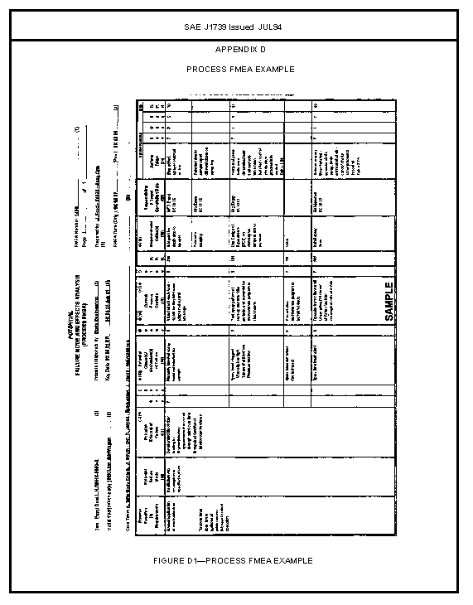
Add: Prevention
Detection to header
Add Model Year / and Program and delete Vehicle

Issued JUL94
APPENDIX I
Figure I, MACHINERY FMEA FORM

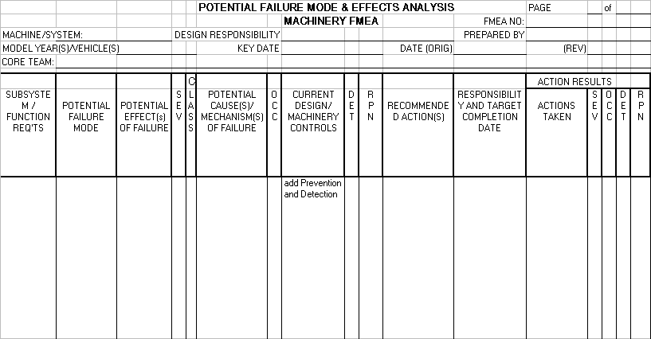

This Figure should be rotated 90 degrees CCW

SAE J1739 Issued JUL94
-39-APPENDIX J
MACHINERY FMEA OCCURRENCE TABLE CALCULATIONS

Appendix J

Occurrence Table Calculations

R(t) = e ^{–t/mtbf}

Failure Rate | MTBF | t (User’s Time) | R(t) | Implication
1 in 1 | 1 | 8 | 0.03% | MTBF is equal to about 10% of the user’s time.
1 in 8 | 8 | 24 | 4.98% | MTBF is equal to about 30% of the user’s time.
1 in 24 | 24 | 40 | 18.89% | MTBF is equal to about 60% of the user’s time.
1 in 80 | 80 | 80 | 36.79% | MTBF is equal to the user’s time.
1 in 350 | 350 | 200 | 60.65% | MTBF is about 2 times greater than the user’s time.
1 in 1000 | 1000 | 250 | 77.88% | MTBF is about 4 times greater than the user’s time.
1 in 2500 | 2500 | 400 | 85.21% | MTBF is about 6 times greater than the user’s time.
1 in 5000 | 5000 | 500 | 90.48% | MTBF is about 10 times greater than the user’s time.
1 in 10000 | 10000 | 500 | 95.12% | MTBF is about 20 times greater than the user’s time.
1 in 25000 | 25000 | 500 | 98.02% | MTBF is about 50 times greater than the user’s time.

SAE J1739 Issued JUL94
APPENDIX K
MACHINERY FMEA EXAMPLE

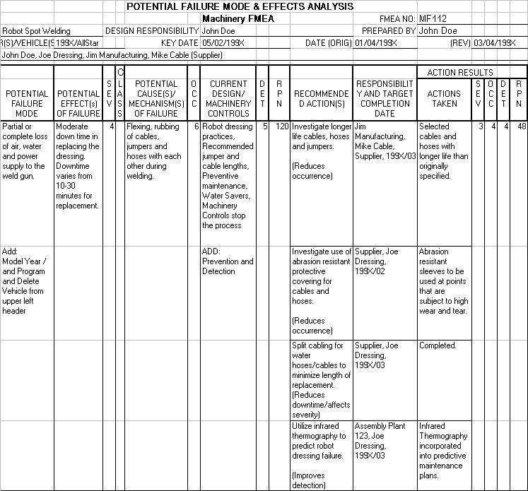
Rotate Figure 90 degrees CCW

APPENDIX L

Glossary

Control Plans—Written description of the system used for controlling the design/manufacturing/assembly process.

Design Intent—List of what a given component/subsystem/system is expected to do or not to do.

Design Life—The time period (e.g., cycles, time, mileage) for which the design is intended to perform its requirements.

Design Validation/Verification (DV)—A program intended to assure that the design meets its requirements.

Design of Experiments (DOE)—Methods which identify factors that affect the mean and variation with minimum testing/experimentation.

Error/Mistake Proofing - Each O.E.M. may have their own unique definition for Error/Mistake Proofing. Confer with the O.E.M. for the appropriate definition.

Feature—A product characteristic (e.g., radius, hardness) or a process characteristic (e.g., insertion force, temperature).

Pareto—A simple tool which can assist problem solving that involves ranking all potential problem areas.

Process—The combination of people, machines and equipment, raw materials, methods and environment that produces a given product or service.

Process Change—A change in processing concept which could alter the capability of the process to meet the design requirements or durability of the product.

Quality Function Deployment (QFD)—A structured method in which customer requirements are translated into appropriate technical requirements for each stage of product development and production.

Root Cause - The single verified reason that accounts for the problem.
A parameter or characteristic that can be controlled and when controlled will prevent a failure mode from occurring
The assignable source of variation that effects all the individual values of the process output and/or phenomenon being studied. The root cause is the reason for the primary non-conformance and is the item that requires change to achieve permanent preventive/corrective action.

Special Product Characteristic—A special product characteristic (e.g., critical, key, major, significant) is a product characteristic for which reasonably anticipated variation could significantly affect a product's safety or compliance with governmental standards or regulations, or is likely to significantly affect customer satisfaction with a product.

Special Process Characteristic—A special process characteristic (e.g., critical, key, major, significant) is a process characteristic for which variation must be controlled to some target value to ensure that variation in a process, or special product characteristic is maintained to its target value during manufacturing and assembly.

Vehicle Campaigns—Recall of vehicles for rework or safety inspection.

SAE J1739 Issued JUL94
Rationale—Not applicable.
Relationship of SAE Standard to ISO Standard—Not Applicable.
Application—This SAE Recommended Practice was jointly developed by DaimlerChrysler Corporation, Ford Motor Company, and General Motors Corporation under the sponsorship of the United States Council for Automotive Research (USCAR).
This document introduces the topic of potential Failure Mode and Effects Analysis (FMEA) and gives general guidance in the application of the technique. An FMEA can be described as a systemized group of activities intended to: (a) recognize and evaluate the potential failure for a product/process and its effects, (b) identify actions which could eliminate or reduce the chance of the potential failure occurring, and (c) document the process. It is complementary to the design process of defining positively what a design must do to satisfy the customer.
Reference Section—There are no referenced publications specified herein.
Developed by the SAE J1739 Task Force (2000)

SAE J1730 TASK FORCE (2000)

MASTER WORKING COMMITTEE

CARL CARLSON - GENERAL MOTORS CORPORATION
WILLIAM CARLSON - DAIMLERCHRYSLER CORPORATION
CYNTHIA TAAFFEE - FORD MOTOR COMPANY
GLEN VALLANCE - FORD MOTOR COMPANY

MACHINERY FMEA SUB-COMMITTEE

DAVID JANAS - DAIMLERCHRYSLER CORPORATION
ADHI KERSALA - GENERAL MOTORS CORPORATION
GARY GIVENS - FORD MOTOR COMPANY

APPENDIX A Design FMEA Quality Objectives
B Process FMEA Quality Objectives
C Block Diagram
D Blank Design FMEA form
E Completed Design FMEA example
F System FMEA
G Blank Process FMEA form
H Completed Process FMEA example
I Blank Machinery FMEA form
J Machinery FMEA occurrence table calculations
K Completed Machinery FMEA example
L Glossary

Y:\data\wpwin61\april97.doc

