'FMEA'- AN EFFECTIVE APPROACH FOR STRENGTHENING IT PROCESSES

1.0 Introduction
Information Technology(IT) has become an important part of business in almost every organisation. With business environment becoming increasingly competitive, the decision making process in organisation has become extremely complex and critical. To day, organisations depend on information technology to make the decision-making faster and simpler. With technological advancements leading to improved reliability, the end user expectations from IT systems are indeed high and it is therefore required to anticipate failures and take necessary preventive actions to minimise failures in IT processes. This paper discusses the complexity of the two IT processes and benefits of using a structured approach “Failure Mode Effect Analysis(FMEA)" to evaluate and minimise the risk associated with potential failures , in meeting the end user expectations.

2.0 Information Technology Processes
The use of Information technology in organisations can be classified in to two broad categories namely
- Information services offered to users (internal customers) for running their applications through Computer Centres/Information centres
- Software development Projects for internal and external customers.
The processes in each of the above critical areas have their own complexities, which need to be addressed carefully in order to meet the high expectations of customers both internal and external. The processes in these two areas are examined below to get a clearer picture of the situation before we explore means of controlling them.

3.0 Information Centre Management :
The concept of Computer information centre, is as old as the computer network itself. Beginning from the days of centralised mainframe computers, where a large no of users are connected to a central computing system, the computer centres have come a long way ,thanks to advent of distributed computing systems. To day, almost every organisation has one or more computer centres (information centres, as they are called) through which the computing services are made available to the users. While the key processes in an information Centre remain the same , additional complexity is brought in the form of managing multiple Information centres as against one in the earlier days , where each Information centre is to be monitored with care to ensure that end-user services are not affected.

  - Processes in an Information Centre
Management of information centre involves management of a number of Processes as mentioned below:
- Environment Management
- Computer operation Management
- Information Security Management
- Performance and Capacity management
- Service level Management
- Change Management
- Problem Management
- Application & Database management
- Consumable/spare parts management
- Document management
- Contingency management :
- Management of Organisation Specific processes
3.2 User Expectations from an Information centre
The end-users in a computing environment are totally dependent on quality of information services. Looking from the users' point of view, they expect uninterrupted System, network and application services to carryout tasks. Apart from these explicit expectations, the users takes for granted the other support systems to be in place, which include
- Prompt help desk services ,
- Timely consumable supplies ,
- Protection against power failures ,
- Preventive and corrective maintenance support
- Effective data management & recovery in case of failures
It is evident that user expectations are indeed very high, with implicit ones far exceeding the explicit ones and this poses the biggest challenge in the management of an information centre.
3.3 Need for a structured approach to assess risks in Information Centre
Comparing the processes in an Information Centre and high expectations of the end-users, it is obvious that each of the above mentioned processes represent high-risk areas where failures may lead to user dissatisfaction. The above processes need to be should be measured, controlled, monitored and reviewed from time to time, if high quality services are to be made available from the information center. Such review of processes would require examination of existing practices and procedures for
- Identification of possible failures that could occur in these processes
- Assessment of risk associated with these potential failures and evaluation of the extent of existing control mechanisms to prevent the failures
- Identify improvement mechanisms to minimise the risk
- Implement and assess the revised risk status
Based on the above, the operational practices and procedures are suitably modified to strengthen the critical processes in an information Centre. In this context of risk assessment, it is highly desirable, if a structured instrument is used to quantify the risk so that extent of process improvements could be measured. This would further facilitate control of critical processes in an information centre and minimise potential risks in a pro-active manner, leading to end-user satisfaction in an organisation.

Customized Software-Challenges
With increased competition, Managers bring in their creativity and own value systems in decision making and prefer information systems customised to their needs / styles of decision making. Development of customized Software product, whether it is carried out internally or externally, is indeed a challenging task. It needs a complete customer focus and is generally complex due to following aspects:
- Initial specifications provided by Customer are only an indication of broad requirements and it is difficult to specify/quantify performance expectations completely prior to development
- Software is often the system element that presents the function to the end user, which is most visible and once the customer looks at the developed work, further specific requirements are imposed.
- In addition to the visible content, it is the background processes and their performance which poses even bigger challenge, particularly in the context of customized Software
- What works for one customer may not exactly suit the other
4.1 Software development Life Cycle
The Software Process life cycle in a typical Software Project can be viewed as consisting of following phases:
- System Feasibility
- Software Plans and requirement
- Product Design
- Detailed Design
- Code
- Integration & testing
- Implementation
During each stage of the above life cycle, the software evolves progressively and this aspect is represented in a model called the Spiral model of software Process.

4.2 Customised Software- User expectations
The initial requirements from customer could be termed as a set of explicit requirements which the proposed application is expected to meet. However as a functional specialist, he assumes certain other implicit requirements are met (such as standards/norms relevant to the application, installability, compatibility, report contents etc) which the Software developer would naturally (!) address and are therefore not normally specified. While a software developer invariably keeps the explicit requirements in constant focus during the development Process, the implicit requirements pose greater challenges in meeting the requirements. From customer's point of view, these implicit requirements represent value addition on the part of the developer. In fact, not meeting these explicit/implicit requirements will be viewed by customer as failure of the customized software and hence should be addressed carefully right through the development phase.

4.3 Software Quality Assurance
The process of Software development involves a large number of things to be done precisely. Hence in order that the Software developed meets the requirements and performs as expected, it is essential that the Software development activities and their outputs at various stages are closely monitored throughout the life cycle phases and this is the main role of Software Quality Assurance (SQA).

4.3.1 Software Reviews/Inspections:
Inspection /review is a powerful mechanism aiding the Software Quality Assurance, with the prime objective being to improve quality of programs by assisting the project team to recognize and fix their own errors right through the development cycle. There are many types of reviews/inspections carried out during the Software Life cycle. Management and Technical reviews are generally conducted to provide information for management action while inspections and walk-throughs are aimed at assisting the Project team in improving their work. Inspections, in particular, are carried out to examine work technically. Software reviews/inspection provide the Project team an independent assessment of areas where improvements are needed keeping customer expectations in view. Reviewers also bring in their expertise to identify, where appropriate, the potential problem areas and assess the risk associated. During inspections these are reviewed with the Project team, existing control mechanisms are inspected and improvements, if any, are agreed upon for implementation. Software reviews / inspections/ testing are typically performed by a team other than the Project team, so as to make review an objective exercise, free from bias.

4.3.2 Structured approach for Software Review -Benefits
The greatest benefit that emerges from software review is that the mechanism itself is oriented towards detection and prevention of errors at various phases of development. While the review process itself is highly structured, the review instrument (containing say checklist, customer expectations/ requirements, risk analysis etc) normally varies from project to project. If structured appropriately, the lessons learnt during development of one project could be shared with other Project teams as well and this is where a structured instrument for review would be beneficial. It is desirable that such an instrument, should have provision for recording potential problem areas, extent of present controls, possible improvement in control mechanisms that could be incorporated and commitments for implementation.

Failure Mode Effects Analysis(FMEA)

5.1 What is Failure mode Effect Analysis (FMEA)?
FMEA is a design and pre-product planning technique which structures the engineer's thought processes to consider every conceivable way in which a component / Product may fail. FMEA also examines the extent of preventive measures built in the System to tackle the potential failures and forms the basis to initiate necessary improvements to prevent occurrence of such failures.

5.2 FMEA Methodology
Failure Mode and Effect Analysis (FMEA) is a technique of a very strict methodology to evaluate a system Design, a process and/or a service for possible ways in which a failure can occur and the present controls, if any, built/designed into the system. Here the intended functions built in the system are examined for possible ways in which the system can fail. For each such failure, an estimate is made of its effect on the total system. The seriousness of the effects is evaluated in terms of three critical parameters namely,
1. Occurrence - How often the failure could occur i.e. frequency of failure as a result of specific cause
2. Severity- How serious the failure is to the customer
3. Detection - Possibility of non-detection of failure before it reaches the customer
Each of the above factors is assigned a numerical ranking (not its value) with higher ranking indicating more frequent the failure. Based on the above, a Risk Priority Number(RPN) is computed as product of above three factors , which is then used to rank the concerns of the system. Where equal risk priority numbers are arrived, severity, detection and occurrence are used in that order to further prioritize them. In light of the computed RPNs, the existing Controls are reviewed regarding the extent of coverage. If not sufficient, further control mechanisms /alternatives are generated, evaluated for extent of improved control (in terms of the same three factors and associated RPN). After such a review, the most appropriate option is chosen for implementation, so as to minimize the associated risk of possible failure and improve the system.

5.3 When to carry out an FMEA?
An FMEA study could be carried out at any stage during development of a product. However the ideal times to use this technique are:
- As the Original concept stage when specifications are established
- As soon as the design is finalized but prior to manufacture
- When the processing decisions are made
- When major changes are to be carried out , either to the Design and Process alterations
- Production Review
- Before dispatch to Customer

5.4 Pre Requisites for doing an FMEA
Prior to carrying out an FMEA, it is necessary to bear a few key aspects:
- Not all problems are important and some failures are more important than others and hence have higher priority than others. FMEA helps identify this priority.
- You must know the requirements of customer i.e., both implicit and explicit requirements
- You must know the function or purpose of what you are trying to accomplish.

5.5 Who should perform FMEA?
In order to be effective, a team must generate the FMEA with the reason being that FMEA should be a catalyst to stimulate the interchange of ideas between the functions affected. Typically a cross-functional and multi -disciplinary team composition with customer perspective is recommended.

5.6 Benefits of FMEA
The major benefits offered by FMEA include
- Improving quality, reliability of the products
- Helping increase Customer satisfaction and hence image of your organization
- Over a period of time, would lead to evolving of useful check list that can be used in reducing development time
- Determining the Redundancy of the System
- Establish a priority for improvement action
- Could be a powerful aid for Product review during various stages of development, prior to delivery

5.7 Limitations of FMEA
FMEA is not a universal tool for identifying all product problems, some of which may be visible only after usage. It is basically an analytical technique, which may be used to examine the functions from customer point of view, so as to minimize failures when used. The technique, when practiced by different teams does not lead to a unique solution and is mainly dependent on how effectively the analysis carried out, thereby making team composition vital for doing the analysis. As the resource requirements of conducting an FMEA is often high and hence if not done in true spirit, it may turn out to be another paper exercise.
  - Impetus for using an FMEA
Meeting customer requirements is, of course, the basic important driving force for doing an FMEA. In addition, it provides a strong basis for continuous improvement during the product/service life cycle. In fact QS 9000 guidelines for automobile companies in their own quality System as well as their supplier certification programs require an FMEA program from their suppliers. Aerospace industry uses FMEA exhaustively to prevent failures in aircraft design/production. It may also be noted that FMEA is an indication of reliability built into the system to perform the intended functions. When the cost involved in product development is very large and performance expectations are high, FMEA offers a mechanism for examining a system for prevention of failures that may occur on usage and to sustain supplier credibility. In short, FMEA can be used as prevention oriented continuous improvement tool to minimise the risks due to failures in situations where customer expectations (implicit/explicit) are high.

6. 0 Relevance of FMEA for IT Processes
6.1 FMEA as an instrument for improving processes in an Information Center
Managing information Centre is an on-going activity in any organisation, where the customer (User) expectations are high. Information centre management assumes even more importance, when the organisation undertakes Software development also, because a well managed Information center is a pre requisite for any development work. FMEA provides an effective approach to assess potential process failures and to evaluate correction mechanisms to minimise risk of failures and strengthening the processes in an Information Centre.
6.2 FMEA for Software Development

6.2.1 FMEA , as an instrument for Software Review
Earlier we examined the need for having a structured instrument that could possibly be used for carrying out Software reviews. FMEA provides the right framework for such review instrument in addressing key issues like
- Potential Failure Mode
- Potential effects of failure
- Severity of failure
- Potential causes /mechanisms of failure
- Current controls to contain possible failure
- Risk assessment & priority associated with failure
- Recommended action
- Responsibility & target completion date
- Action taken and revised risk status
The structured approach adopted in FMEA offers an additional benefit of storing the review outcome in an organization-wide database for easy access and distribution.

FMEA for System Testing
It may be recalled that the purpose of system test is to find those areas in which the system does not work as intended, regardless of specifications. In other words, system testing looks for potential failures that a customer could encounter and this is precisely the impetus behind FMEA. Thus FMEA could form the basis for arriving at suitable test cases for System Testing in general and for formulating tests in meeting the implicit expectation of customer.

FMEA- Experiences in NSDRC

7.1 NSDRC organisational Background

National Ship Design and Research Centre (NSDRC) , Visakhapatnam is a premier Ship Design and Consultancy organisation under Ministry of Surface Transport. NSDRC provides indigenous Ship design capabilities so as to improve productivity in Indian Shipyards, Ports and Ship Owners. The organisation derives its strength from its team of Naval Architects, Marine Engineers, Mechanical Engineers and Computer Engineers backed up by a team of experienced consultants. NSDRC uses IT extensively for execution of Ship Design, Consultancy and Software Development Projects for its Clientele.

7.2 Ship Design Process
Basic Design of a ship is an iterative process, wherein beginning from a broad set of Owner's requirements, selection of ship dimensions, hull form,power,Hull & machinery arrangements are progressively worked out. The basic Design, charecterised by what is known as Basic design spiral(Fig2) consists of four major stages as mentioned below:
- Concept Design: This is the first effort, which translates the mission requirements into naval architectural and engineering characteristics. It aims at arriving at a preliminary estimate of the fundamental elements of the proposed ship as length,beam,depth ,draft ,power etc which meet the owner's requirements namely required speed ,range,cargo and deadweight.
- Preliminary Design: During this phase, the major ship characteristics affecting cost and performance are further refined The output of this phase provides a precise definition of a vessel that meet the mission requirements and forms the basis for development of contract plans and specifications.
- Contract Design : This phase encompasses one or more loops around the Design spiral thereby further strengthening the preliminary design and delineates more precisely features such as hull form based on a fair set of lines, powering based on model testing , Weight and centre of gravity of the ship are worked out precisely at this stage
- Detailed Design: This is the final stage of Ship design where detailed working plans are generated for installation and construction of individual items
Review process is the most critical for the ship Design process and in each of the above stages, the design evolved is critically reviewed for conformance to owner requirements, Class requirements, safety requirements etc.
7.3 PROJECT MANAGEMENT IN NSDRC
NSDRC adopts matrix structure of organisation for its Project management, where one member is associated with multiple projects and Project teams are cross-functional. While the Ship Design processes are common, the implementation of these processes in specific Projects vary depending on Ship Type, Size, Cargo etc.
  - Review Process in NSDRC
Ship Design itself is a creative and iterative process where the owner's requirements are progressively refined so as to arrive at an optimised design. However, in view of the high costs involved in design and development of a ship, any design errors detected much later in the life cycle are very expensive to rectify. Hence review process is extremely critical in Ship Design projects and carried out at appropriate stages of Design to ensure high quality Ship Design meeting the Owners expectations.
The Project review teams are identified on the basis of expertise required for each Project and process of Review normally varies from one project to another, depending on review team, Project requirements etc. In this connection, a need was felt for a mechanism to exchange/share the design/review experiences across the projects, so that lessons learnt in one Project can be used in another to prevent occurrence of similar errors.
7.5 Use of FMEA in NSDRC

NSDRC has recognised the usefulness of FMEA as an effective tool to prevent errors in delivery of products and services. As the computer services form the backbone for both Ship design and consultancy projects, it was decided to experiment FMEA approach to
- To improve the processes in the Information Centre
- System Testing of a software development project prior to delivery of Customised software for one of its clients.

7.6.1 FMEA analysis for the Information Centre services

In order to ensure improved System services, an FMEA analysis was carried out for system management Processes in the information Centre and an example of two instances, where the analysis resulted in minimising the risk of potential failures, is placed at Fig 3.
    - FMEA analysis for a Software Product

A customised Software was developed for one of our Clientele and prior to delivery. As delivery date was fixed at a short notice, there was a need to perform system testing within a short time frame. In order to formulate the test cases, an FMEA was carried out taking into consideration the implicit requirements of the client and the analysis for the software product discovered errors associated with
- Report contents and presentation
- Presence of unwanted events in forms
- Installability
- Target environment(date format , specific printer etc)
- Trapping of unforeseen errors
which otherwise have possibly escaped attention as many of the above are implicit expectations and the time frame available was limited. The illustration of FMEA for two specific problem areas, is placed at Fig 4.Encouraged by the success of application of FMEA approach in the above areas NSDRC is now adopting FMEA as a tool for reviewing Ship Design and Software development projects .

8.0 Conclusion
With organisations adopting Information Technology for meeting the requirements of Customers, management of Information technology processes in an organisation assumes great importance. In order to ensure that IT processes operate in a controlled environment, one should be able to evaluate processes and take needed preventive measures to prevent potential failures. In this connection, it is beneficial to use a structured instrument in analyzing risks against potential failures and /or not meeting the customer expectations. Failure mode Effect analysis (FMEA) is one such instrument which strengthens the IT processes, in ensuring development of high quality IT services & Software products, leading to customer delight.

References:

i) Management of Software process by Humphrey (Addison Wesley)
ii) TQM Engineering Handbook by Stamatis (Marcel Decker)
iii) Software Engineering , A practitioner's approach by Roger S. Pressman(Mcgraw Hill Intl.)
iv) Software Engineering by R.Thayer (IEEE Computer Press)
v) Quality Control Handbook by Juran (Mcgraw Hill intl.)
vi) Ship Design and Construction by Robert Taggart

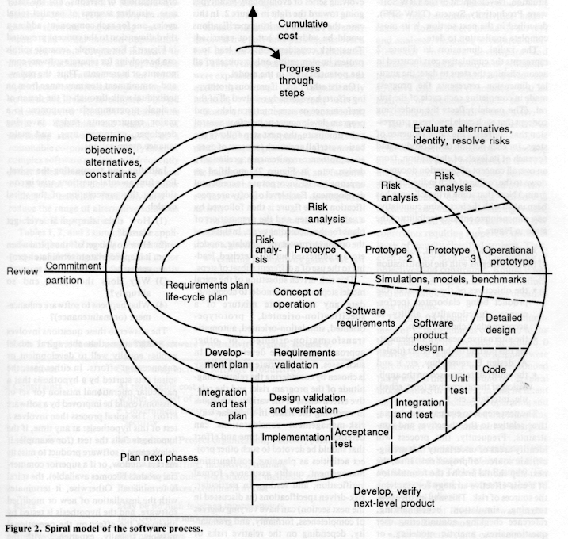
Figure 1. Spiral Model for Software Process
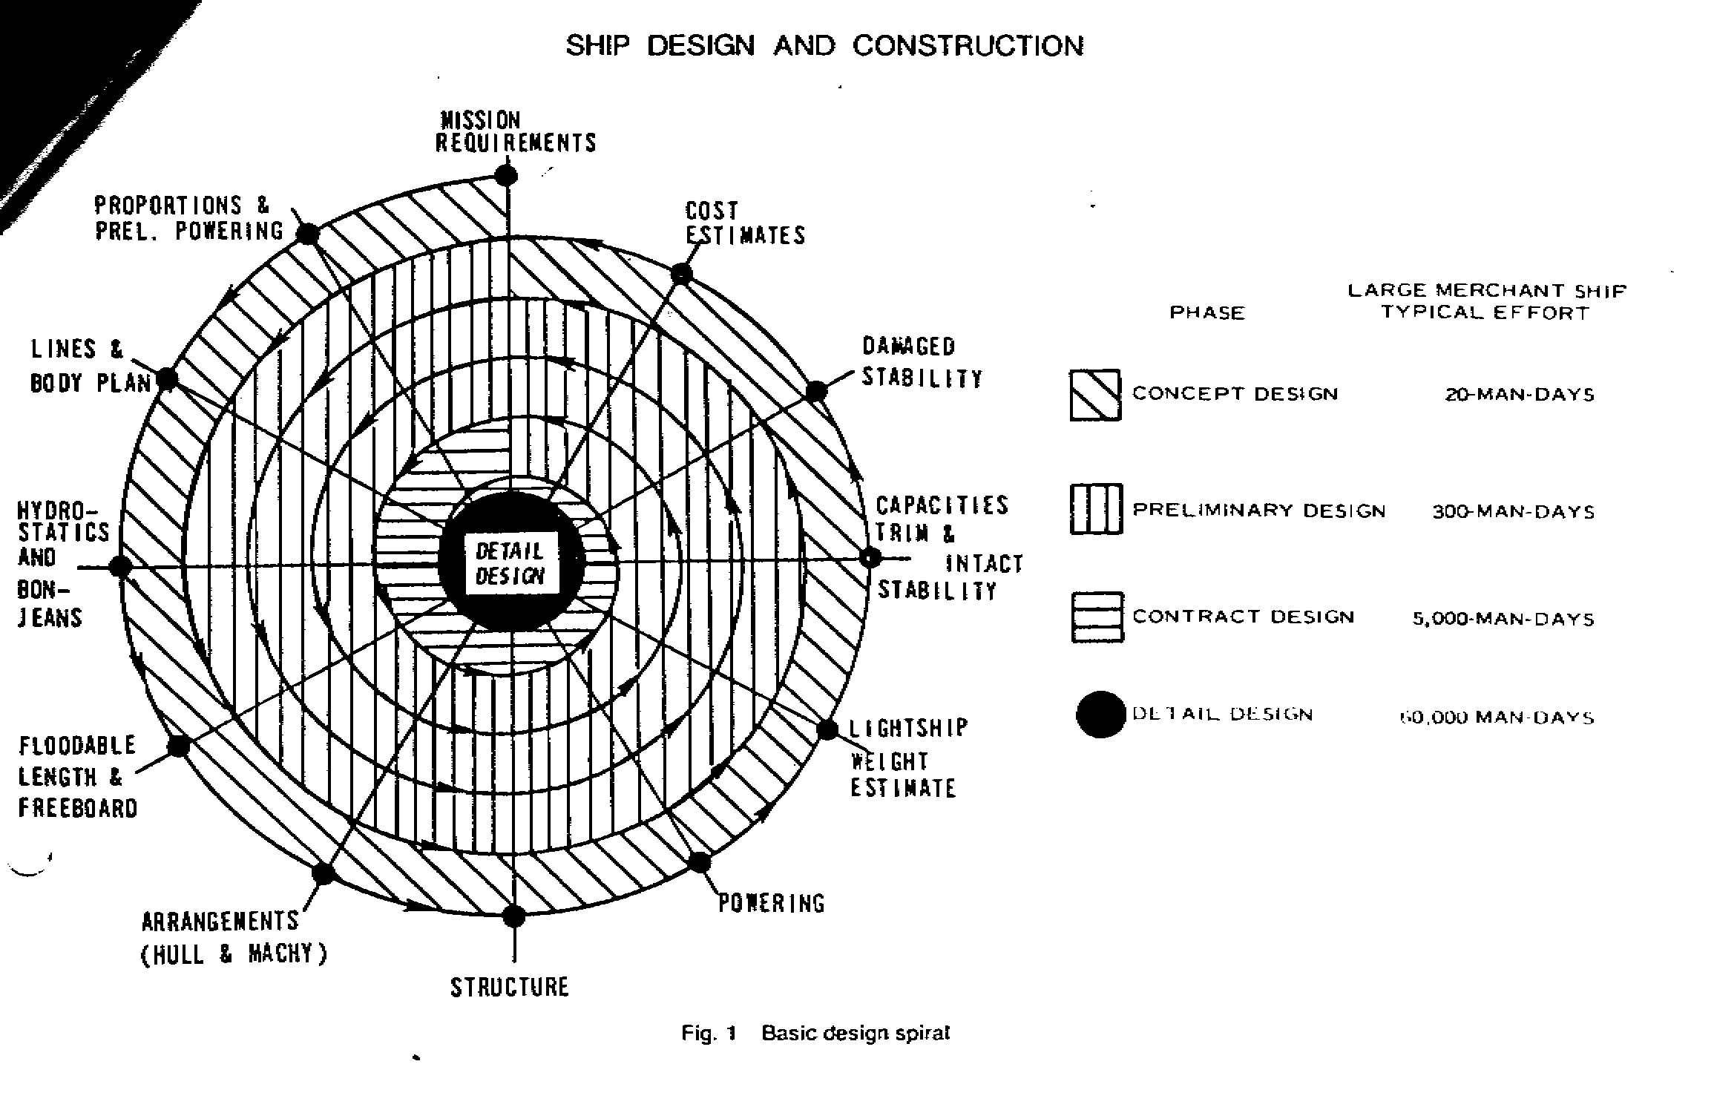
2
Fig2 Basic Design Spiral

Fig 3 : FMEA for System testing for Software Projects

Potential Function  Requirements | Potential  Failure Mode | Potential effects  Of failure | S  E  V | Potential Causes/  Mechanism(s) of Failure | O  C  C  U  R | Current Design  Controls | D  E  T  E  C  T | R  P  N | Recommended  Action | Responsibility & Target Completion date | Action Results
 |  |  |  |  |  |  |  |  |  |  | Action Taken | S  E  V | OCC | D  E  T | R  P  N
Printing of graphic Screen content to a default Printer | When the targeted printer does not match with the design specification | O/P is not suitable for printing on the given paper | 8 | Default font is not supported by the printer selected | 9 | Printing with a default font on to a certain printer | 6 | 432 | Supply of various fonts, so that user can choose a font that suits the target printer | Mr. PSP Chakravarthy | Invoked a font dialogue & option of selecting a suitable font is given and the last selected font is stored | 8 | 2 | 2 | 32
Display of Date / month | When the date is not as per expected format (dd-mmm-yyyy)  In correct | The date is processed incorrectly which results in wrong output | 6 | user environment has different date settings | 4 | dd/mm/yy settings for system is assumed and first two digits of date are extracted | 9 | 216 | A way of accepting & processing of date in a predefined format need to be implemented , irrespective of system date format. | Mr. PSP Chakravarthy | Wherever system date is accepted or processed, it is first converted into prescribed format & then processed | 6 | 1 | 1 | 6

Fig 4 : FMEA for System management (Windows NT) in Information Centre

Potential Function  Requirements | Potential  Failure Mode | Potential effects  Of failure | S  E  V | Potential Causes/  Mechanism(s) of Failure | O  C  C  U  R | Current Design  Controls | D  E  T  E  C  T | R  P  N | Recommended  Action | Responsibility & Target Completion date | Action Results
 |  |  |  |  |  |  |  |  |  |  | Action Taken | S  E  V | OCC | D  E  T | R  P  N
System time should be uniform in all Servers and Clients in the Network , to ensure consistency in handling of dates in applications. | When the nodes in the network used the system time/date from local nodes and time setting differs from node to node. | In correct date & time recorded in applications from different nodes at the same time. | 8 | When the node uses local time settings and time settings vary from node to node | 7 | Time settings on nodes were done from a specific Server manually | 3 | 168 | To implement a scheme for synchronization of time settings across the nodes | System administrator | Three Specific Servers were identified for maintaining the time. Nodes are configured to take time/date settings from any of these three servers, on a periodical basis. The three servers themselves were synchronized to have common settings. | 8 | 1 | 3 | 24
Sufficient disk storage should be available in the identified Disk in the Network. | When large no of users share the same storage volume, there is danger of disk becoming full suddenly | Users will not be able to save the current work | 6 | Absence of a disk quota mechanism for users | 4 | Manually checking for free disk space | 9 | 216 | To ensure periodically availability of enough free disk area to prevent failures due to space non-availability. | System administrator | A program developed to check periodically for the existing free disk space and give advanced warning signals at various levels of occupancy to System administrator | 6 | 1 | 1 | 6

